|  |  |  |  |  |  |  |
| --- | --- | --- | --- | --- | --- | --- |
| |  |  |  |  | | --- | --- | --- | --- | | **logo ngan.png** | | **MINISTRY OF EDUCATION AND TRAINING** | | | **FPT UNIVERSITY** | | |
| Capstone Project Document |
| Maid Services |
| |  |  |  |  |  |  |  |  |  |  |  | | --- | --- | --- | --- | --- | --- | --- | --- | --- | --- | --- | | |  |  | | --- | --- | | **Group 06 – Report 1** | | | **Group member** | Bùi Tiến Tuân - Team Leader - SE60824  Mạnh Quang Tuyến - Team Member - SE60890  Trương Hải Đăng - Team Member - SE60841  Nguyễn Tấn Công - Team Member - SE60920 | | **Supervisor** | Mr. Nguyễn Trọng Tài | | **Ext. Supervisor** | N/A | | **Capstone Project code** | MS | | |

-Ho Chi Minh City, 09/2014-

# Table of Contents

Table of Contents 2

2.1 User Requirement Specification 3

2.1.1 Guest requirement 3

2.1.3 Staff requirement 3

2.1.4 Customer requirement 3

2.1.5 Maid mediator requirement 4

2.1.6 Webmaster requirement 4

2.1.7 System requirement 4

2.2 System Requirement Specification 4

2.2.1 External Interface Requirements 4

2.2.1.1 User Interfaces 4

2.2.1.2 Hardware Interfaces 4

2.2.1.3 Software Interfaces 4

2.2.1.4 Communications Protocol 5

2.2.2 System Features 5

2.2.2.1 List of use case 5

2.2.2.2 Use Case model: 6

2.2.2.3 Use-case diagram 7

2.2.3 Software System Attributes 98

2.2.3.1 Reliability 98

2.2.3.2 Availability 98

2.2.3.3 Security 98

2.2.3.4 Maintainability 98

2.2.3.5 Portability 98

2.2.3.6 Performance 98

2.3 Entity Relationship Diagram or Data Structures 100

3. Other material (if any) 100



## User Requirement Specification

|  |  |
| --- | --- |
| Actor | Description |
| **Guest** | A person not login. They have some simple function search. |
| **Staff** | A person help staff and customer connect together and post job request for Maid |
| **Customer** | Hiring maids. They can search, comment rating for job request posted by Maid or Maid Mediator. |
| **Maid Mediator** | They help maid post job request. |
| **Maid** | They can post job request. |
| **Webmaster** | They manager website. |
| **System** | Implement suggestions. |

### Guest requirement

To satisfy the demand of guest, system has these functions:

* **Register Account:** guest need to register to become member.
* **Login:** when guest have account they can login with username and password.
* **Search:** guest can search information about jobs, before they determine become a member.
* **View JobRequest:** view JobRequest details.
* **View Recruitment:** view Recruitment details.
  + 1. **Authenticated User requirement**

After logging in, user becomes authenticated user and has these functions:

* **View Profile:** user can view profile.
* **Log out:** user can log out .
* **View JobRequest:** view JobRequest details.
* **View Recruitment:** view Recruitment details.
* **View Notifications:** view Notifications when system sends.
* **View Statistic:** view personal statistic.

### Staff requirement

A person: to manage the maid’s request, fee and allow maid to post request.

* **Manage post time**: staff manage maid’s request post time.
* **View post time**: staff can allow customer and maid the time that maid’s request posted.
* **Manage fee**: staff can manage the customer’s fee, maid’s fee
* **Confirm request**: staff can allow the maid’s request to post to the website.

### Customer requirement

A person:

* **Search maids**:
* **Rating**:
* **Comment**:
* **Manage recruitment**:
* **View customer statistic**:

### Maid mediator requirement

A person:

* **Apply job**:
* **Search jobs**:
* **Manage job request**:
* **View maid statistic**:

### Webmaster requirement

A person:

* **Manager user**:

### System requirement

A person:

* **Suggests**:
* **Handle unconfirmed request**:
* **Notify**:

## System Requirement Specification

### External Interface Requirements

#### User Interfaces

* The general interface of website is simple and simplifies user interfaces.
* The design is simple and monochrome is more prefer.
* The layout of information in page is showing simple but full of functions.
* The error, warning and notification messages must be simple, neat, and easy to understand. Error warning does not discomfort to the user.
* The working layout of user is spacious.
* Member can contact with manager and admin easily.

#### Hardware Interfaces

There is no extra hardware interfaces are needed. The system will use the standard hardware and data communications resources of a standard computer.

#### Software Interfaces

Browsers: Firefox, Chrome

#### Communications Protocol

BSF website uses HTTP/HTTPS protocol for communication with the web browser and the web server. In addition, TCP/IP network protocol for communication with HTTP protocol

### System Features

#### List of use case

|  |  |  |  |  |  |  |  |  |
| --- | --- | --- | --- | --- | --- | --- | --- | --- |
| No. | Use case name | Use case ID | Guest | Staff | Customer | Maid mediator | Webmaster | System |
| 1 | Register Account | 001 | x |  |  |  |  |  |
| 2 | Login | 002 | x |  |  |  |  |  |
| 3 | Search | 003 | x | x | x | x | x |  |
| 4 | Search by Age | 004 | x | x | x | x | x |  |
| 5 | Search by Skill | 005 | x | x | x | x | x |  |
| 6 | Search by Gender | 006 | x | x | x | x | x |  |
| 7 | Search by Salary | 007 | x | x | x | x | x |  |
| 8 | Search by Time | 008 | x | x | x | x | x |  |
| 9 | View Job Request | 009 | x | x | x | x | x |  |
| 10 | View Recruitment | 010 | x | x | x | x | x |  |
| 11 | View Profile | 011 | x | x | x | x | x |  |
| 12 | Log out | 012 | x | x | x | x | x |  |
| 13 | View Notifications | 013 |  | x | x | x | x |  |
| 14 | Add Staff | 014 |  |  |  |  | x |  |
| 15 | Manage User | 015 |  |  |  |  | x |  |
| 16 | Ban Account | 016 |  |  |  |  | x |  |
| 17 | Unban Account | 017 |  |  |  |  | x |  |
| 18 | View Requests Statistic | 018 |  | x |  |  | x |  |
| 19 | View Income Statistic | 019 |  | x |  |  | x |  |
| 20 | Manage Config | 020 |  |  |  |  | x |  |
| 21 | Suggest | 021 |  |  |  |  |  | x |
| 22 | Send SMS | 022 |  |  |  |  |  | x |
| 23 | Send Notifications | 023 |  |  |  |  |  | x |
| 24 | Apply Job Request | 024 |  |  | x |  |  |  |
| 25 | Comment Job Request | 025 |  |  | x |  |  |  |
| 26 | Rate Job Request | 026 |  |  | x |  |  |  |
| 27 | Edit Customer Profile | 027 |  |  | x |  |  |  |
| 28 | Extend Recruitment | 028 |  |  | x |  |  |  |
| 29 | Hide Recruitment | 029 |  |  | x |  |  |  |
| 30 | Public Recruitment | 030 |  |  | x |  |  |  |
| 31 | Post Recruitment | 031 |  |  | x |  |  |  |
| 32 | Edit Recruitment | 032 |  |  | x |  |  |  |
| 33 | Pay | 033 |  |  | x |  |  |  |
| 34 | View Customer Statistic | 034 |  |  | x |  |  |  |
| 35 | Add Maid | 035 |  | x |  | x |  |  |
| 36 | View Maid | 036 |  | x |  | x |  |  |
| 37 | Edit Maid | 037 |  | x |  | x |  |  |
| 38 | Public Job Request | 038 |  | x |  | x |  |  |
| 39 | Hide Job Request | 039 |  | x |  | x |  |  |
| 40 | Extend Job Request | 040 |  | x |  | x |  |  |
| 41 | Edit Job Request | 041 |  | x |  | x |  |  |
| 42 | Edit Maid Mediator Profile | 042 |  |  |  | x |  |  |
| 43 | Post Job Request | 043 |  | x |  | x |  |  |
| 44 | Active Job Request | 044 |  | x |  |  |  |  |
| 45 | Active Recruitment | 045 |  | x |  |  |  |  |
| 46 | Approve Job Request | 046 |  | x |  |  |  |  |
| 47 | View Maid Manager Statistic | 047 |  | x |  | x |  |  |
| 48 | Manage Number of Kmean | 048 |  |  |  |  | x |  |
| 49 | Manage Number of Weeks | 049 |  |  |  |  | x |  |
| 50 | Manage Job Request Price | 050 |  |  |  |  | x |  |
| 51 | Manage Recruitment Price | 051 |  |  |  |  | x |  |
| 52 | Manage Job Request | 052 |  | x |  |  |  |  |
| 53 | Manage Recruitment | 053 |  | x |  |  |  |  |
| 54 | Manage Applied Job Request | 054 |  | x |  |  |  |  |
| 55 | Manage Sub Price | 055 |  |  |  |  | x |  |

#### Use Case model:

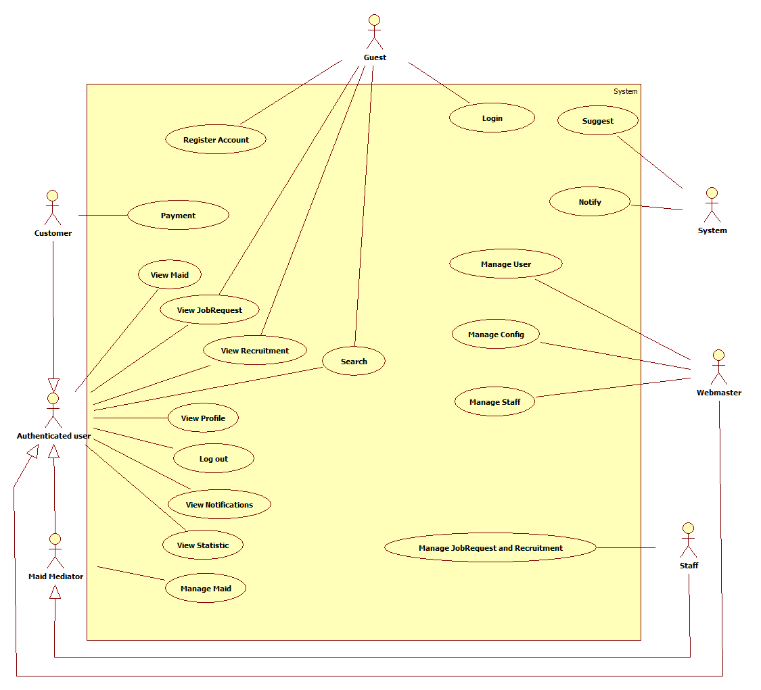

#### Use-case diagram

##### <Guest> Register

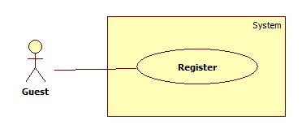

|  |  |  |  |  |
| --- | --- | --- | --- | --- |
| **USE CASE SPECIFICATION** | | | | |
| **Use-case No.** | UC001 | **Use-case Version** | | 1.0 |
| **Use-case Name** | Register | | | |
| **Author** | CongNT | | | |
| **Date** | 21/09/2014 | **Priority** | High | |
| **Actor:** Guest  **Summary:** This use case allows guest to create an account in website system.  **Goal:**  It helps guest to create an account on website.  **Trigger:** Click on the “Đăng ký” button to register on home page  **Pre-conditions:**   * Page is loaded successfully * Register page will be shown   **Post conditions:**   * Success: Register successfully, guest will have an account in system and will be logged into system. * Failure: Show message error.   **Main Success Scenario:**   |  |  | | --- | --- | | Actor Action | System Response | | 1. Click on “Đăng ký” button home page 2. Input right information about username, email, password, full name, phone, role 3. Click on the “Đăng ký” button [Alternative 1] | 2. System redirect to register page for guest, contain a register form :   * Tên tài khoản [Username: textbox ] * Mật khẩu [Password : textbox] * Nhập lại mật khẩu [Repassword : textbox] * Địa chỉ email [Email: textbox]   In format: /^([a-zA-Z0-9_\.\-])+\@(([a-zA-Z0-9\-])+\.)+([a-zA-Z0-9]{2,4})+$/ .   * Họ và tên [Fullname : textbox] * Điện thoại[Phone : textbox] * Vai trò[Role : dropdownlist] * Đăng ký[button]  1. Validate valid username, password, email, phone 2. Redirect to login page |   **Alternative Scenario:**   |  |  | | --- | --- | | Actor Action | System Response | | 1. [Alternative 1] Click on the “MaidService” icon. | 1. Back to home page |   **Exceptions:**   |  |  | | --- | --- | | Actor Action | System Response | | 1. “Tên đăng nhập” is emtpy 2. “”Mật khẩu” is empty 3. “Nhập lại mật khẩu” if different with “Mật khẩu” 4. “Điện thoại” is empty or not a numberic value 5. “Họ và tên” is empty 6. “Email” is empty or not correct type [abc@abc.abc](mailto:abc@abc.abc) 7. “Tên đăng nhập” is already have in database | 1. Display message: “Vui lòng nhập tên đăng nhập” 2. Display message: “Vui lòng nhập mật khẩu” 3. Display message: “Mật khẩu không trùng khớp” 4. Display message: “Vui lòng nhập số” 5. Display message: “Vui lòng nhập họ và tên” 6. Display message: “Vui lòng nhập đúng định dạng [abc@abc.abc](mailto:abc@abc.abc)” 7. Display message: “Tên đăng nhập đã tồn tại” |   **Relationships:** N/A  **Business Rules:** When register an account, username have to input username, email, password, phone.   * If username is already have in database or empty, an error message will be displayed. * If password is empty, an error message will be displayed. * If confirm password is not the same as password, an error message will be displayed. * If phone is empty or not a numberic value, an error message will be displayed. | | | | |

##### <Guest> Login

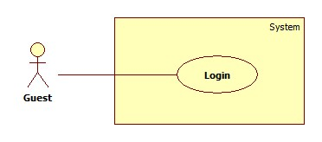

|  |  |  |  |  |
| --- | --- | --- | --- | --- |
| **USE CASE SPECIFICATION** | | | | |
| **Use-case No.** | UC002 | **Use-case Version** | | 1.0 |
| **Use-case Name** | Login | | | |
| **Author** | CongNT | | | |
| **Date** | 21/09/2014 | **Priority** | High | |
| **Actor:** Guest  **Summary:** This use case allow guest to login the website  **Goal:** Guest become a member of the website  **Trigger:** Click on the “Đăng nhập” button to login on home page  **Pre-conditions:**   * Page is loaded successfully * The login page will shown   **Post conditions:**   * Success: Login successfully, guest will have a role in system and can use more function of system. * Failure: Show message error   **Main Success Scenario:**   |  |  | | --- | --- | | Actor Action | System Response | | 1. Click on “Đăng nhập” button home page 2. Input right information about username, password 3. Click on the “Đăng nhập” button | 1. System redirect to login page for guest, contain a login form :  * Tên tài khoản [Username: textbox ] * Mật khẩu [Password : textbox] * Đăng nhập [button]  1. Redirect to login successful page |   **Alternative Scenario:**   |  |  | | --- | --- | | Actor Action | System Response | | 1. [Alternative 1] Click on the “Đóng” button. | 1. Back to home page |   **Exceptions:**   |  |  | | --- | --- | | Actor Action | System Response | | 1. “Tên đăng nhập”,”Mật khẩu” ,” is empty 2. “Tên đăng nhập”,”Mật khẩu” ,” is incorrect 3. “Tên đăng nhập” is IsActive(false) | 1. Display message “Vui lòng nhập tên đăng nhập” or “Vui lòng nhập mật khẩu” 2. Display message “Tên đăng nhập hoặc mật khẩu không đúng, vui lòng thử lại” 3. Display message “Tên đăng nhập đã bị khóa” |   **Relationships:** N/A  **Business Rules:** User must input username, password. The username and password must unique and have in database and the username is not blocked. If the username is blocked or not unique or not have in database, an error message is displayed. | | | | |

##### <Authenticated user > Search

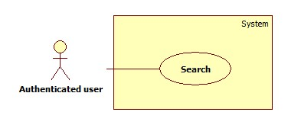

|  |  |  |  |  |
| --- | --- | --- | --- | --- |
| **USE CASE SPECIFICATION** | | | | |
| **Use-case No.** | UC003 | **Use-case Version** | | 1.0 |
| **Use-case Name** | Search | | | |
| **Author** | CongNT | | | |
| **Date** | 21/09/2014 | **Priority** | High | |
| **Actor:** Guest, Customer, Maid Mediator, Staff, Webmaster.  **Summary:** This use case allow guest can search information by job  **Goal:** Guest can search information by search job  **Trigger:** Fill in “Tìm kiếm” textbox, then click on “Tìm kiếm” button  **Pre-conditions:**   * Page is loaded successfully * The search page will shown   **Post conditions:**   * Success: Search successfully, the system will shown search result * Failure:   **Main Success Scenario:**   |  |  | | --- | --- | | Actor Action | System Response | | 1. Fill in “Tìm kiếm” text box 2. Click on “Tìm kiếm” button | 1. System redirect to search page for guest and show search results |   **Alternative Scenario:**   |  |  | | --- | --- | | Actor Action | System Response | | 1. [Alternative 1] Click on the “MaidService” icon | 1. Back to home page |   **Exceptions:**   |  |  | | --- | --- | | Actor Action | System Response | |  |  |   **Relationships:** N/A  **Business Rules:** All of role can search but search results are different in some roles:   * If user is a guest, search results are jobrequests and recruitments. * If user is a staff, customer or webmaster, search results are jobrequests and recruitments. * If user is a maid mediator, search results are jobrequests. | | | | |

##### < Authenticated user >Advance Search

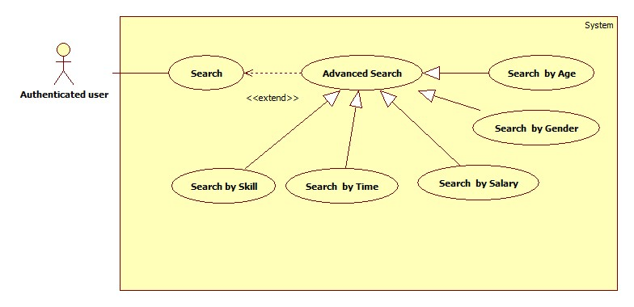

###### **<Authenticated user> Search by Age**

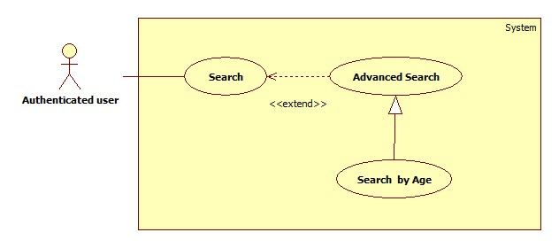

|  |  |  |  |  |
| --- | --- | --- | --- | --- |
| **USE CASE SPECIFICATION** | | | | |
| **Use-case No.** | UC004 | **Use-case Version** | | 1.0 |
| **Use-case Name** | Search by age | | | |
| **Author** | CongNT | | | |
| **Date** | 21/09/2014 | **Priority** | High | |
| **Actor:** Guest, Customer, Maid Mediator, Staff, Webmaster.  **Summary:** This use case allow guest can search information by age  **Goal:** Guest can search information by search age  **Trigger:** Click on age radio button on website  **Pre-conditions:**   * Page is loaded successfully * The search page will shown   **Post conditions:**   * Success: Search successfully, the system will shown search result * Failure:   **Main Success Scenario:**   |  |  | | --- | --- | | Actor Action | System Response | | 1. Fill in “Tìm kiếm” text box 2. Click on “Tìm kiếm” button 3. Click on “25-30” or “30-35” or “35-40” link | 1. System redirect to search page for guest 2. Show the result suitable for each link |   **Alternative Scenario:**   |  |  | | --- | --- | | Actor Action | System Response | | 1. [Alternative 1] Click on the “Đóng” button. | 1. Back to home page |   **Exceptions:**   |  |  | | --- | --- | | Actor Action | System Response | |  |  |   **Relationships:** N/A  **Business Rules:** All of role can search but search results are different in some roles:   * If user is a guest, search results are jobrequests and recruitments. * If user is a staff, customer or webmaster, search results are jobrequests and recruitments. * If user is a maid mediator, search results are jobrequests. | | | | |

###### **<Authenticated user> Search by Skill**

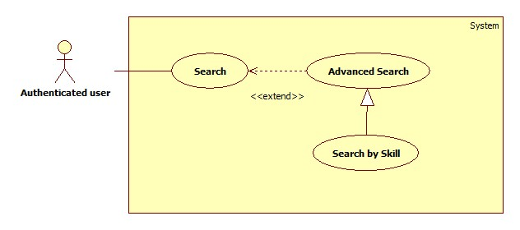

|  |  |  |  |  |
| --- | --- | --- | --- | --- |
| **USE CASE SPECIFICATION** | | | | |
| **Use-case No.** | UC005 | **Use-case Version** | | 1.0 |
| **Use-case Name** | Search by skill | | | |
| **Author** | CongNT | | | |
| **Date** | 21/09/2014 | **Priority** | High | |
| **Actor:** Guest, Customer, Maid Mediator, Staff, Webmaster.  **Summary:** This use case allow guest can search information by skill  **Goal:** Guest can search information by search skill  **Trigger:** Click on skill radio button on website  **Pre-conditions:**   * Page is loaded successfully * The search page will shown   **Post conditions:**   * Success: Search successfully, the system will shown search result * Failure:   **Main Success Scenario:**   |  |  | | --- | --- | | Actor Action | System Response | | 1. Fill in “Tìm kiếm” text box 2. Click on “Tìm kiếm” button 3. Click on skill radio button | 1. System redirect to search page 2. Show the result suitable for each button |   **Alternative Scenario:**   |  |  | | --- | --- | | Actor Action | System Response | | 1. [Alternative 1] Click on the “Đóng” button. | 1. Back to home page |   **Exceptions:**   |  |  | | --- | --- | | Actor Action | System Response | |  |  |   **Relationships:** N/A  **Business Rules:** All of role can search but search results are different in some roles:   * If user is a guest, search results are jobrequests and recruitments. * If user is a staff or webmaster, search results are jobrequests and recruitments. * If user is a maid mediator, search results are recruitment. * If user is a customer, search results are jobrequests. | | | | |

###### **<Authenticated user> Search by Gender**

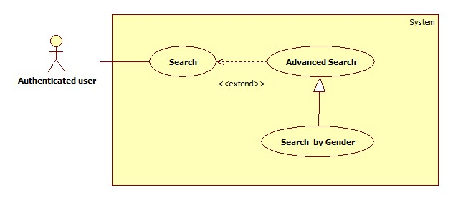

|  |  |  |  |  |
| --- | --- | --- | --- | --- |
| **USE CASE SPECIFICATION** | | | | |
| **Use-case No.** | UC006 | **Use-case Version** | | 1.0 |
| **Use-case Name** | Search by gender | | | |
| **Author** | CongNT | | | |
| **Date** | 21/09/2014 | **Priority** | High | |
| **Actor:** Guest, Customer, Maid Mediator, Staff, Webmaster.  **Summary:** This use case allow guest can search information by gender  **Goal:** Guest can search information by search name  **Trigger:** Click on gender radio button on website  **Pre-conditions:**   * Page is loaded successfully * The search page will shown   **Post conditions:**   * Success: Search successfully, the system will shown search result * Failure:   **Main Success Scenario:**   |  |  | | --- | --- | | Actor Action | System Response | | 1. Fill in “Tìm kiếm” text box 2. Click on “Tìm kiếm” button 3. Click on “Nam” or “Nữ” link | 1. System redirect to search page for guest 2. Show the result suitable for each link |   **Alternative Scenario:**   |  |  | | --- | --- | | Actor Action | System Response | | 1. [Alternative 1] Click on the “Đóng” button. | 1. Back to home page |   **Exceptions:**   |  |  | | --- | --- | | Actor Action | System Response | |  |  |   **Relationships:** N/A  **Business Rules:** All of role can search but search results are different in some roles:   * If user is a guest, search results are jobrequests and recruitments. * If user is a staff, customer or webmaster, search results are jobrequests and recruitments. * If user is a maid mediator, search results are jobrequests. | | | | |

###### **<Authenticated user> Search by Salary**

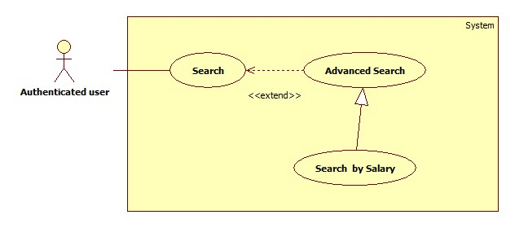

|  |  |  |  |  |
| --- | --- | --- | --- | --- |
| **USE CASE SPECIFICATION** | | | | |
| **Use-case No.** | UC007 | **Use-case Version** | | 1.0 |
| **Use-case Name** | Search by salary | | | |
| **Author** | CongNT | | | |
| **Date** | 21/09/2014 | **Priority** | High | |
| **Actor:** Guest, Customer, Maid Mediator, Staff, Webmaster.  **Summary:** This use case allow guest can search information by salary  **Goal:** Guest can search information by search salary  **Trigger:** Click on salary radio button on website  **Pre-conditions:**   * Page is loaded successfully * The search page will shown   **Post conditions:**   * Success: Search successfully, the system will shown search result * Failure:   **Main Success Scenario:**   |  |  | | --- | --- | | Actor Action | System Response | | 1. Fill in “Tìm kiếm” text box 2. Click on “Tìm kiếm” button 3. Click on “Dưới 3 triệu” or “3-5 triệu” or “trên 5 triệu” link | 1. System redirect to search page for guest 2. Show the result suitable for each link |   **Alternative Scenario:**   |  |  | | --- | --- | | Actor Action | System Response | | 1. [Alternative 1] Click on the “Đóng” button. | 1. Back to home page |   **Exceptions:**   |  |  | | --- | --- | | Actor Action | System Response | |  |  |   **Relationships:** N/A  **Business Rules:** All of role can search but search results are different in some roles:   * If user is a guest, search results are jobrequests and recruitments. * If user is a staff, customer or webmaster, search results are jobrequests and recruitments. * If user is a maid mediator, search results are jobrequests. | | | | |

###### **<Authenticated user> Search by Time**

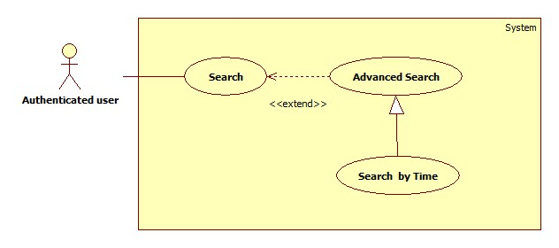

|  |  |  |  |  |
| --- | --- | --- | --- | --- |
| **USE CASE SPECIFICATION** | | | | |
| **Use-case No.** | UC008 | **Use-case Version** | | 1.0 |
| **Use-case Name** | Search by time | | | |
| **Author** | CongNT | | | |
| **Date** | 21/09/2014 | **Priority** | High | |
| **Actor:** Guest, Customer, Maid Mediator, Staff, Webmaster.  **Summary:** This use case allow guest can search information by time  **Goal:** Guest can search information by search time  **Trigger:** Click on time radio button on website  **Pre-conditions:**   * Page is loaded successfully * The search page will shown   **Post conditions:**   * Success: Search successfully, the system will shown search result * Failure:   **Main Success Scenario:**   |  |  | | --- | --- | | Actor Action | System Response | | 1. Fill in “Tìm kiếm” text box 2. Click on “Tìm kiếm” button 3. Click on “Cách đây 1 ngày” or “Cách đây 3 ngày” or “Cách đây 5 ngày” or “Cách đây 7 ngày” or “Cách đây 14 ngày” or “Cách đây 30 ngày” link | 1. System redirect to search page for guest 2. Show the result suitable for each link |   **Alternative Scenario:**   |  |  | | --- | --- | | Actor Action | System Response | | 1. [Alternative 1] Click on the “Đóng” button. | 1. Back to home page |   **Exceptions:**   |  |  | | --- | --- | | Actor Action | System Response | |  |  |   **Relationships:** N/A  **Business Rules:** All of role can search but search results are different in some roles:   * If user is a guest, search results are jobrequests and recruitments. * If user is a staff, customer or webmaster, search results are jobrequests and recruitments. * If user is a maid mediator, search results are jobrequests. | | | | |

##### <Authenticated user> View JobRequest

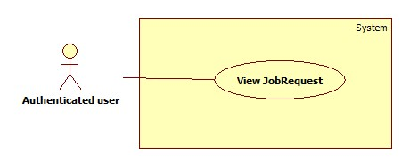

|  |  |  |  |  |
| --- | --- | --- | --- | --- |
| **USE CASE SPECIFICATION** | | | | |
| **Use-case No.** | UC009 | **Use-case Version** | | 1.0 |
| **Use-case Name** | View jobrequest | | | |
| **Author** | CongNT | | | |
| **Date** | 21/09/2014 | **Priority** | High | |
| **Actor:** Staff, Customer, Maid Mediator, Webmaster  **Summary:** This use case allow to view jobrequest  **Goal:** User can view jobrequest detail  **Trigger:** Click on title jobrequest link  **Pre-conditions:**   * Page is loaded successfully * User login to website successful   **Post conditions:**   * Success: Login successfully * Failure:   **Main Success Scenario:**   |  |  | | --- | --- | | Actor Action | System Response | | 1. Login to website 2. Click title jobrequest link | 1. System redirect home page 2. System redirect jobrequest detail page. |   **Alternative Scenario:**   |  |  | | --- | --- | | Actor Action | System Response | |  |  |   **Exceptions:**   |  |  | | --- | --- | | Actor Action | System Response | |  |  |   **Relationships:** N/A  **Business Rules:**   * If user log in as customer, user must click “Người tìm việc” tab, then click title jobrequest link. * If user is a guest or login as a staff, maid mediator, webmaster, user click title jobrequest link. | | | | |

##### <Authenticated user> View Recruitment

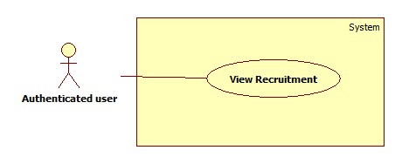

|  |  |  |  |  |
| --- | --- | --- | --- | --- |
| **USE CASE SPECIFICATION** | | | | |
| **Use-case No.** | UC010 | **Use-case Version** | | 1.0 |
| **Use-case Name** | View recruitment | | | |
| **Author** | CongNT | | | |
| **Date** | 21/09/2014 | **Priority** | High | |
| **Actor:** Staff, Customer, Maid Mediator, Webmaster, Guest  **Summary:** This use case allow to view jobrequest  **Goal:** User can view recruitment detail  **Trigger:** Click on title recruitment link  **Pre-conditions:**   * Page is loaded successfully * User login to website successful   **Post conditions:**   * Success: Login successfully * Failure:   **Main Success Scenario:**   |  |  | | --- | --- | | Actor Action | System Response | | 1. Login to website 2. Click “Việc tìm người” tab 3. Click title recruitment link | 1. System redirect home page 2. System redirect recruitment page. 3. System redirect recruitment detail page. |   **Alternative Scenario:**   |  |  | | --- | --- | | Actor Action | System Response | |  |  |   **Exceptions:**   |  |  | | --- | --- | | Actor Action | System Response | |  |  |   **Relationships:** N/A  **Business Rules:**   * If user log in as a staff, maid mediator, webmaster, user must click “Việc tìm người” tab, then click title recruitment link. * If user is a guest or login as a customer user click title recruitment link. | | | | |

##### <Authenticated user> View Profile

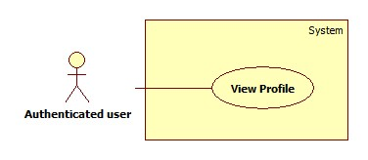

|  |  |  |  |  |
| --- | --- | --- | --- | --- |
| **USE CASE SPECIFICATION** | | | | |
| **Use-case No.** | UC011 | **Use-case Version** | | 1.0 |
| **Use-case Name** | View Profile | | | |
| **Author** | CongNT | | | |
| **Date** | 21/09/2014 | **Priority** | High | |
| **Actor:** Staff, Customer, Maid Mediator, Webmaster  **Summary:** This use case allow user to see his/her profile  **Goal:** User can see his/her profile  **Trigger:** Click on title jobrequest link  **Pre-conditions:**   * Page is loaded successfully * User login as to website successful   **Post conditions:**   * Success: Login successfully, user can see his/her profile * Failure:   **Main Success Scenario:**   |  |  | | --- | --- | | Actor Action | System Response | | 1. Login to website 2. Click name link | 1. System redirect home page 2. System redirect personal profile page |   **Alternative Scenario:**   |  |  | | --- | --- | | Actor Action | System Response | | 1. Click on the “Đăng xuất” button. | 1. Clear session and back to home page |   **Exceptions:**   |  |  | | --- | --- | | Actor Action | System Response | |  |  |   **Relationships:** N/A  **Business Rules:**   * If login as a staff, then click name link,website will redirect to staff’s profile page. Staff could see profile of all members. * If login as a maid mediator, then click name link,website will redirect to maid mediator’s profile page. * If login as a customer, then click name link,website will redirect to customer’s profile page. * If login as a webmaster, then click name link,website will redirect to config page. | | | | |

##### <Authenticated user> Log out

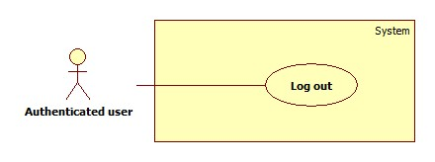

|  |  |  |  |  |
| --- | --- | --- | --- | --- |
| **USE CASE SPECIFICATION** | | | | |
| **Use-case No.** | UC012 | **Use-case Version** | | 1.0 |
| **Use-case Name** | Log out | | | |
| **Author** | CongNT | | | |
| **Date** | 21/09/2014 | **Priority** | High | |
| **Actor:** Staff, Customer, Maid Mediator, Webmaster, Guest  **Summary:** This use case allow to log out website  **Goal:** User can log out website  **Trigger:** Click on log out button  **Pre-conditions:**   * Page is loaded successfully * User login to website successful   **Post conditions:**   * Success: Login successfully * Failure:   **Main Success Scenario:**   |  |  | | --- | --- | | Actor Action | System Response | | 1. Login to website 2. Click log out | 1. System redirect home page 2. System redirect home page and clear session. |   **Alternative Scenario:**   |  |  | | --- | --- | | Actor Action | System Response | |  |  |   **Exceptions:**   |  |  | | --- | --- | | Actor Action | System Response | |  |  |   **Relationships:** N/A  **Business Rules:** User must log in to website. | | | | |

##### <Authenticated user> View Notifications

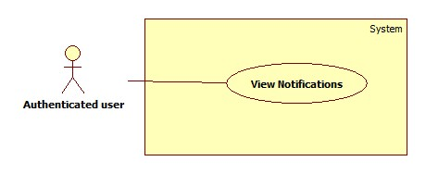

|  |  |  |  |  |
| --- | --- | --- | --- | --- |
| **USE CASE SPECIFICATION** | | | | |
| **Use-case No.** | UC013 | **Use-case Version** | | 1.0 |
| **Use-case Name** | View notifications | | | |
| **Author** | CongNT | | | |
| **Date** | 21/09/2014 | **Priority** | High | |
| **Actor:** Staff, Customer, Maid Mediator, Webmaster  **Summary:** This use case allow to view notifications  **Goal:** User can view notifications  **Trigger:** Click on title icon notifications link  **Pre-conditions:**   * Page is loaded successfully * User login to website successful   **Post conditions:**   * Success: Login successfully * Failure:   **Main Success Scenario:**   |  |  | | --- | --- | | Actor Action | System Response | | 1. Login to website 2. Click icon notifications link | 1. System redirect home page 2. System redirect notifications page. |   **Alternative Scenario:**   |  |  | | --- | --- | | Actor Action | System Response | |  |  |   **Exceptions:**   |  |  | | --- | --- | | Actor Action | System Response | |  |  |   **Relationships:** N/A  **Business Rules:**   * If user log in as a staff, notifications show that jobrequests or recruitments is not active or is not paid, so staff have to active those jobrequests or recruitments. * If user log in as a customer or maid mediator, notifications show that your recruitmenst or jobrequests are applied. | | | | |

##### <Webmaster> Add Staff

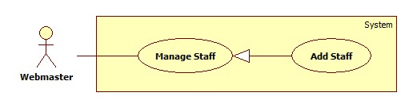

|  |  |  |  |  |
| --- | --- | --- | --- | --- |
| **USE CASE SPECIFICATION** | | | | |
| **Use-case No.** | UC014 | **Use-case Version** | | 1.0 |
| **Use-case Name** | Add staff | | | |
| **Author** | TuanBT | | | |
| **Date** | 24/09/2014 | **Priority** | High | |
| **Actor:** Webmaster  **Summary:** Webmaster add a user role Staff. A new staff only have username and password.  **Goal:** Make a new user directive.  **Trigger:**Webmater click on “Thêm nhân viên”  **Pre-conditions:**   * User must login with Admin role. * Register page will be shown   **Post conditions:**   * Success: Reload this page * Failure: Show message error   **Main Success Scenario:**   |  |  | | --- | --- | | Actor Action | System Response | | 1. Webmaster click “Thêm nhân viên” at his profile page.  3. Webmaster fill and click “Thêm nhân viên” button. | 2. The page show 3 input username, password, re-password.  4. Page is reload.  [Exception 1] [Exception 2] |   **Alternative Scenario:**   |  |  | | --- | --- | | Actor Action | System Response | |  |  |   **Exceptions:**   |  |  | | --- | --- | | Actor Action | System Response | | [Exception 1]  1. Input “Tên đăng ký” is missing  [Exception 1]  1. Input “Mật khẩu” is missing or password not match with input “Nhập lại mật khẩu” | 2. Show error “Vui lòng nhập tên đăng nhập”  2. Show error “Mật khẩu không trùng khớp” |   **Relationships:** Add staff is generalization of manage staff  **Business Rules:** N/A | | | | |

##### <Staff> View Staff Statistic

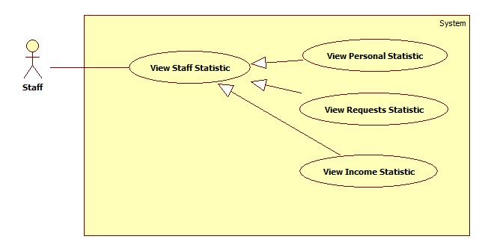

###### **<Staff> View Requests Statistic**

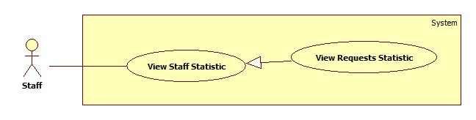

|  |  |  |  |  |
| --- | --- | --- | --- | --- |
| **USE CASE SPECIFICATION** | | | | |
| **Use-case No.** | UC018 | **Use-case Version** | | 1.0 |
| **Use-case Name** | View Requests Statistic | | | |
| **Author** | CongNT | | | |
| **Date** | 21/09/2014 | **Priority** | High | |
| **Actor:** Staff, Webmaster  **Summary:** This use case allow staff see requests statistic  **Goal:** Staff can see requests statistic  **Trigger:** Click on “Các yêu cầu” link  **Pre-conditions:**   * Page is loaded successfully * User login as staff successful   **Post conditions:**   * Success: Login successfully, the statistic will be shown * Failure:   **Main Success Scenario:**   |  |  | | --- | --- | | Actor Action | System Response | | 1. Login as a staff 2. Click name link 3. Click “Thống kê” link 4. Click “Các yêu cầu” link | 1. System redirect home page 2. System redirect personal profile page 3. System redirect personal statistic page and show personal statistic. 4. System redirect personal statistic page and show personal statistic. |   **Alternative Scenario:**   |  |  | | --- | --- | | Actor Action | System Response | | 1. Click on the “Đăng xuất” button. | 1. Clear session and back to home page |   **Exceptions:**   |  |  | | --- | --- | | Actor Action | System Response | | 1. System fail to load data | 1. Show message “Hệ thống đang bảo trì” |   **Relationships:** N/A  **Business Rules:** User login as a staff. | | | | |

###### **<Staff> View Income Statistic**

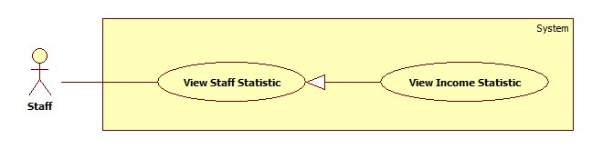

|  |  |  |  |  |
| --- | --- | --- | --- | --- |
| **USE CASE SPECIFICATION** | | | | |
| **Use-case No.** | UC019 | **Use-case Version** | | 1.0 |
| **Use-case Name** | View Income Statistic | | | |
| **Author** | CongNT | | | |
| **Date** | 21/09/2014 | **Priority** | High | |
| **Actor:** Staff, Webmaster  **Summary:** This use case allow staff see income statistic  **Goal:** Staff can see income statistic  **Trigger:** Click on “Doanh thu” link  **Pre-conditions:**   * Page is loaded successfully * User login as staff successful   **Post conditions:**   * Success: Login successfully, the income statistic will be shown * Failure:   **Main Success Scenario:**   |  |  | | --- | --- | | Actor Action | System Response | | 1. Login as a staff 2. Click name link 3. Click “Thống kê” link 4. Click “Doanh thu” link | 1. System redirect home page 2. System redirect personal profile page 3. System redirect personal statistic page and show personal statistic. 4. System redirect income statistic page and show personal statistic. |   **Alternative Scenario:**   |  |  | | --- | --- | | Actor Action | System Response | | 1. Click on the “Đăng xuất” button. | 1. Clear session and back to home page |   **Exceptions:**   |  |  | | --- | --- | | Actor Action | System Response | | 1. System fail to load data | 1. Show message “Hệ thống đang bảo trì” |   **Relationships:** N/A  **Business Rules:** User login as a staff | | | | |

##### <Webmaster> Banned Account

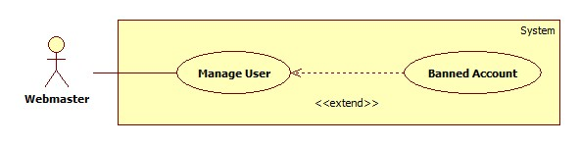

|  |  |  |  |  |
| --- | --- | --- | --- | --- |
| **USE CASE SPECIFICATION** | | | | |
| **Use-case No.** | UC016 | **Use-case Version** | | 1.0 |
| **Use-case Name** | Bannned Account | | | |
| **Author** | TuanBT | | | |
| **Date** | 24/09/2014 | **Priority** | High | |
| **Actor:** Webmaster  **Summary:** Webmaster will banned account.  **Goal:**  Banned Account.  **Trigger:** Webmaster click “Khóa tài khoản”  **Pre-conditions:**   * User must login with Admin role * Banned Account page will be shown   **Post conditions:**   * Success: Reload this page. Button will change to “Kích hoạt” * Failure: Do not reload page   **Main Success Scenario:**   |  |  | | --- | --- | | Actor Action | System Response | | 1. Webmaster click “Khóa tài khoản” menu, then click “Khóa” button. | 2. Reload page and change button to “Kích hoạt” |   **Alternative Scenario:**   |  |  | | --- | --- | | Actor Action | System Response | |  |  |   **Exceptions:**   |  |  | | --- | --- | | Actor Action | System Response | |  |  |   **Relationships:** Banned Account extend of manage user  **Business Rules:** N/A | | | | |

##### <Webmaster> Active Account

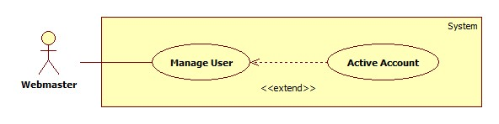

|  |  |  |  |  |
| --- | --- | --- | --- | --- |
| **USE CASE SPECIFICATION** | | | | |
| **Use-case No.** | UC017 | **Use-case Version** | | 1.0 |
| **Use-case Name** | Active Account | | | |
| **Author** | TuanBT | | | |
| **Date** | 24/09/2014 | **Priority** | High | |
| **Actor:** Webmaster  **Summary:** Webmaster will active account.  **Goal:** Active account.  **Trigger:** Webmaster click “Kích hoạt”  **Pre-conditions:**   * User must login with Admin role * Active Account page will be shown   **Post conditions:**   * Success: Reload this page. Button will change to “Khóa” * Failure: Do not reload page   **Main Success Scenario:**   |  |  | | --- | --- | | Actor Action | System Response | | 1. Webmaster click “Khóa tài khoản” menu, then click “Kích hoạt” button. | 2. Reload page and change button to “Khóa” |   **Alternative Scenario:**   |  |  | | --- | --- | | Actor Action | System Response | |  |  |   **Exceptions:**   |  |  | | --- | --- | | Actor Action | System Response | |  |  |   **Relationships:** Active Account extend of Manage acount  **Business Rules:** N/A | | | | |

##### <Webmaster> View Request Statistic

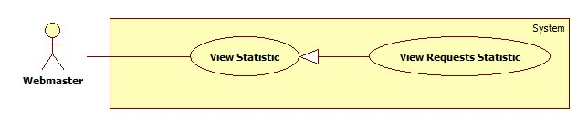

|  |  |  |  |  |
| --- | --- | --- | --- | --- |
| **USE CASE SPECIFICATION** | | | | |
| **Use-case No.** | UC001 | **Use-case Version** | | 1.0 |
| **Use-case Name** | View requests Statistic | | | |
| **Author** | TuanBT | | | |
| **Date** | 24/09/2014 | **Priority** | High | |
| **Actor:** Webmaster  **Summary:** View statistic of all request of MS-Website in year.  **Goal:**  View statistic  **Trigger:** Webmaster click “Thống kê”  **Pre-conditions:**   * User must login with Admin role * Statistic page will be shown   **Post conditions:**   * Success: Show statistic chart * Failure: Do not show chart   **Main Success Scenario:**   |  |  | | --- | --- | | Actor Action | System Response | | 1. Webmaster click “Thống kê” menu then click “Các yêu cầu” link. | 2. Show statistic chart. |   **Alternative Scenario:**   |  |  | | --- | --- | | Actor Action | System Response | |  |  |   **Exceptions:**   |  |  | | --- | --- | | Actor Action | System Response | |  |  |   **Relationships:** View Request Statistic is generalization of View Statistic  **Business Rules:** N/A | | | | |

##### <Webmaster> View Income Statistic

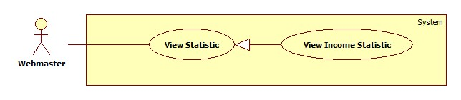

|  |  |  |  |  |
| --- | --- | --- | --- | --- |
| **USE CASE SPECIFICATION** | | | | |
| **Use-case No.** | UC001 | **Use-case Version** | | 1.0 |
| **Use-case Name** | View Income Statistic | | | |
| **Author** | TuanBT | | | |
| **Date** | 24/09/2014 | **Priority** | High | |
| **Actor:** Webmaster  **Summary:** View statistic of all request of MS-Website in year.  **Goal:**  View statistic  **Trigger:** Webmaster click “Thống kê”  **Pre-conditions:**   * User must login with Admin role * Statistic page will be shown   **Post conditions:**   * Success: Show statistic chart * Failure: Do not show chart   **Main Success Scenario:**   |  |  | | --- | --- | | Actor Action | System Response | | 1. Webmaster click “Thống kê” menu then click “Doanh thu” link. | 2. Show statistic chart. |   **Alternative Scenario:**   |  |  | | --- | --- | | Actor Action | System Response | |  |  |   **Exceptions:**   |  |  | | --- | --- | | Actor Action | System Response | |  |  |   **Relationships:** View Income Statistic is generalization of View Statistic  **Business Rules:** N/A | | | | |

##### <System> Suggest JobRequest

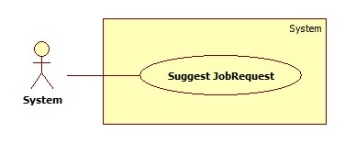

|  |  |  |  |  |
| --- | --- | --- | --- | --- |
| **USE CASE SPECIFICATION** | | | | |
| **Use-case No.** | UC021 | **Use-case Version** | | 1.0 |
| **Use-case Name** | Suggest JobRequest | | | |
| **Author** | TuanBT | | | |
| **Date** | 24/09/2014 | **Priority** | High | |
| **Actor:** System  **Summary:** system automatically suggest JobRequest for customer when they post a recruitment on MS-Website.  **Goal:**  The use case will help MS-Website suggest JobRequest for customer when they post a recruitment.  **Trigger:**   * Click [Đăng yêu cầu tuyển việc] button. * Fill all data. * Click [Đăng yêu cầu] button.   **Pre-conditions:**   * Post an invalid recruitment.   **Post conditions:**   * Success: Suggested JobRequests list will appear. * Failure: Nothing is displayed at suggesting field.   **Main Success Scenario:**   |  |  | | --- | --- | | Actor Action | System Response | | 1. User click on the [Đăng yêu cầu tuyển việc] button.   [Alternative 1] | 1. Show suggested JobRequests list.   [Exception 1] |   **Alternative Scenario:**   |  |  | | --- | --- | | Actor Action | System Response | | 1. User click on the [Đăng yêu cầu] button. | 1. Show suggested JobRequests list. |   **Exceptions:**   |  |  | | --- | --- | | Actor Ation | System Response | | 1. System fail to load data | 1. Show suggested JobRequests list |   **Relationships:** N/A  **Business Rules:**  When customer posts a Recruitment, the system will use Kmean Algorithms to put this Recruitment in a group. The system will show up to 10 JobRequests with status “Waiting” and isActive is True in the same group. The JobRequests list will be arranged in order of descending by distance from the center point of that group. | | | | |

##### <System> Send SMS

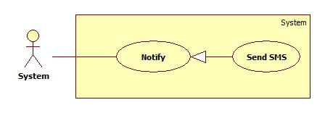

|  |  |  |  |  |
| --- | --- | --- | --- | --- |
| **USE CASE SPECIFICATION** | | | | |
| **Use-case No.** | UC022 | **Use-case Version** | | 1.0 |
| **Use-case Name** | Send SMS | | | |
| **Author** | TuanBT | | | |
| **Date** | 24/09/2014 | **Priority** | Normal | |
| **Actor:** System  **Summary:** Notify for Maid, Customer, Maid Mediator or Staff when Customer apply JobRequest of Maid.  **Goal:**  Send SMS for Maid, Customer, Maid Mediator or Staff when Customer apply JobRequest of Maid. System know when accept a job.  **Trigger:** Both Customer and Maid post an invalid recruitment and job request. Customer must apply successful JobRequest.  **Pre-conditions:**   * Apply success.   **Post conditions:**   * Success: Send SMS * Failure: Don’t send SMS   **Main Success Scenario:**   |  |  | | --- | --- | | Actor Action | System Response | | 1. Customer apply JobRequest of Maid | 1. Send SMS   [Exception 1] |   **Alternative Scenario:**   |  |  | | --- | --- | | Actor Action | System Response | | N/A | N/A |   **Exceptions:**   |  |  | | --- | --- | | Actor Action | System Response | | 1. Number is blank | 1. No |   **Relationships:** Send SMS is generalization of Notification  **Business Rules:** System will send SMS, help maid, customer, Maid mediator or staff know when request of them apply. | | | | |

##### <System> Send Notifications

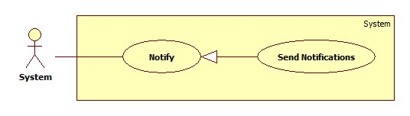

|  |  |  |  |  |
| --- | --- | --- | --- | --- |
| **USE CASE SPECIFICATION** | | | | |
| **Use-case No.** | UC023 | **Use-case Version** | | 1.0 |
| **Use-case Name** | Send Notifications | | | |
| **Author** |  | | | |
| **Date** | 24/09/2014 | **Priority** | Normal | |
| **Actor:** System  **Summary:** Notify for Maid, Customer, Maid Mediator or Staff when Customer apply JobRequest of Maid. Notify for all Staff when customer report about payment.  **Goal:**  Help user know what happen with them.  **Trigger:** Both Customer and Maid post an invalid recruitment and job request. Customer must apply successful JobRequest.  **Pre-conditions:**   * User must login into MS-Website.   **Post conditions:**   * Success: Notification show at notify page of User was send Notification. * Failure: Do not show notification.   **Main Success Scenario:**   |  |  | | --- | --- | | Actor Action | System Response | | 1. Customer apply JobRequest of Maid | 1. Send SMS |   **Alternative Scenario:**   |  |  | | --- | --- | | Actor Action | System Response | | N/A | N/A |   **Exceptions:**   |  |  | | --- | --- | | Actor Action | System Response | |  |  |   **Relationships:** Send notificatrion is generalization of Notifier  **Business Rules:** System will send notification, help maid, customer, Maid mediator or staff know when request of them apply. | | | | |

##### <Customer> Apply JobRequest

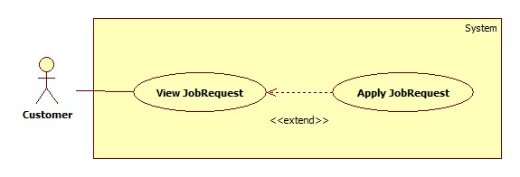

|  |  |  |  |  |
| --- | --- | --- | --- | --- |
| **USE CASE SPECIFICATION** | | | | |
| **Use-case No.** | UC024 | **Use-case Version** | | 1.0 |
| **Use-case Name** | Apply JobRequest | | | |
| **Author** | TuanBT | | | |
| **Date** | 24/09/2014 | **Priority** | High | |
| **Actor:** Customer  **Summary:** Customer use a them Recruitment have status “Waiting” to Apply a JobRequest have status “Waiting” too.  **Goal:**  Apply JobRequest.  **Trigger:** Click button “Thuê"  **Pre-conditions:**   * User must login with Customer role   **Post conditions:**   * Success: Reload page. Name of Customer show at status line. * Failure: Show error “Thuê thất bại”   **Main Success Scenario:**   |  |  | | --- | --- | | Actor Action | System Response | | 1. Customer click a JobRequest have status “Waiting”, then click “Thuê” button.  3. Choose a Recruitment from list Radio button. Then click “Đồng ý” button | 2. Show modal “Xin chọn một đơn tuyển việc”.  4. Show status “Đã được thuê”.  [Exception1] |   **Alternative Scenario:**   |  |  | | --- | --- | | Actor Action | System Response | | [Alternative 1]  1. Customer click a Recruitment in Profile page. Recruitment in tab “Chờ thuê”.  3. Customer click one of them.  5. Click “Thuê” button  7. Click “Chấp nhận” button. | 2. System show some JobRequest in “Những việc có thể hợp” box.  4. System show “Chi tiết yêu cầu công việc” page.  6. System show modal “Xác nhận thuê”.  8. Show status “Đã được thuê”.  [Exception1] |   **Exceptions:**   |  |  | | --- | --- | | Actor Action | System Response | | [Exception 1]  1. Customer click “Chấp nhận” from modal. | 2. Show error “Công việc đã được thuê bởi khách hàng khác” |   **Relationships:** Apply JobRequest is extend of View JobRequest  **Business Rules:**  JobRequest must have status “Waiting”. Have two cases when applying JobRequest: Choose a JobRequest from suggestion of system in Recruitment detail, choose JobRequest from Index or Search. In first case, system automatic choose current Recruitment to apply suggested JobRequest. The second case, customer have to choose one of Recruitments List, if they don’t have any Recruitment, they must post a recruitment.  Sometime this JobRequest is applied by another customer or expired by that time. Customer can not apply JobRequest and receive an error. | | | | |

##### <Customer> Comment JobRequest

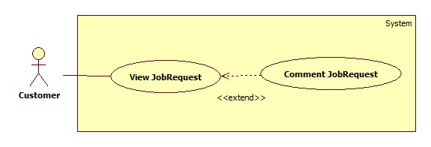

|  |  |  |  |  |
| --- | --- | --- | --- | --- |
| **USE CASE SPECIFICATION** | | | | |
| **Use-case No.** | UC025 | **Use-case Version** | | 1.0 |
| **Use-case Name** | Comment JobRequest | | | |
| **Author** | TuanBT | | | |
| **Date** | 24/09/2014 | **Priority** | High | |
| **Actor:** Customer  **Summary:** When customer applied a JobRequest, they can comment for this JobRequest if Maid come back and tell to staff Approved this Job.  **Goal:**  Comment JobRequest.  **Trigger:** Fill input comment.  **Pre-conditions:**   * User must login with Admin role * Status of JobRequest is Approved   **Post conditions:**   * Success: one line comment show. * Failure: No comment.   **Main Success Scenario:**   |  |  | | --- | --- | | Actor Action | System Response | | 1. Click a jobRequest in “Đã nhận” tab. This JobRequest must have status “Đã hoàn tất”  3. Fill comment input, then click “Đăng” button. | 2. Show box “Nhận xét của người đã thuê”.  4. One line comment is show. |   **Alternative Scenario:**   |  |  | | --- | --- | | Actor Action | System Response | |  |  |   **Exceptions:**   |  |  | | --- | --- | | Actor Action | System Response | |  |  |   **Relationships:** Comment JobRequest is extend of View JobRequest  **Business Rules:** JobRequest must have Approved status which means “Đã hoàn tất”, customer can only comment on this JobReuest. | | | | |

##### <Customer> Rate JobRequest

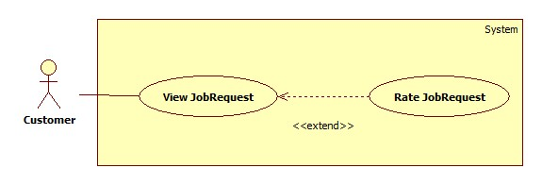

|  |  |  |  |  |
| --- | --- | --- | --- | --- |
| **USE CASE SPECIFICATION** | | | | |
| **Use-case No.** | UC026 | **Use-case Version** | | 1.0 |
| **Use-case Name** | Rate JobRequest | | | |
| **Author** | TuanBT | | | |
| **Date** | 24/09/2014 | **Priority** | High | |
| **Actor:** Customer  **Summary:** When customer applied a JobRequest, they can rate for this JobRequest if Maid come back and tell to staff Approved this Job.  **Goal:**  Rate JobRequest.  **Trigger:** Click choose star. Then click “Chấm điểm” button.  **Pre-conditions:**   * User must login with Admin role * Status of JobRequest is Approved   **Post conditions:**   * Success: Star show in rating line. * Failure: No rate.   **Main Success Scenario:**   |  |  | | --- | --- | | Actor Action | System Response | | 1. Click a jobRequest in “Đã nhận” tab. This JobRequest must have status “Đã hoàn tất”  3. Choose number star, then click “Chấm điểm” button. | 2. Show box “Nhận xét của người đã thuê”.  4. Rate of JobRequest be shown. |   **Alternative Scenario:**   |  |  | | --- | --- | | Actor Action | System Response | |  |  |   **Exceptions:**   |  |  | | --- | --- | | Actor Action | System Response | |  |  |   **Relationships:** Rate JobRequest is extend of View JobRequest  **Business Rules:** JobRequest must have Approved status which mean “Đã hoàn tất”, customer can only Rate on this JobReuest. | | | | |

##### <Customer> Edit Customer Profile

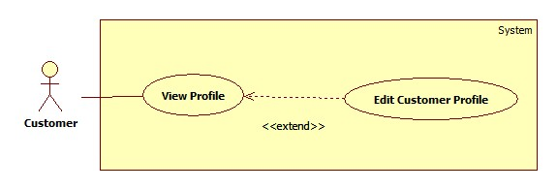

|  |  |  |  |  |
| --- | --- | --- | --- | --- |
| **USE CASE SPECIFICATION** | | | | |
| **Use-case No.** | UC027 | **Use-case Version** | | 1.0 |
| **Use-case Name** | Edit Customer Profile | | | |
| **Author** | TuanBT | | | |
| **Date** | 24/09/2014 | **Priority** | High | |
| **Actor:** Customer  **Summary:** …  **Goal:**  …  **Trigger:** …  **Pre-conditions:**   * User must login with Admin role * … page will be shown   **Post conditions:**   * Success: ... * Failure: ….   **Main Success Scenario:**   |  |  | | --- | --- | | Actor Action | System Response | | 1. | 2. |   **Alternative Scenario:**   |  |  | | --- | --- | | Actor Action | System Response | |  |  |   **Exceptions:**   |  |  | | --- | --- | | Actor Action | System Response | | [Exception 1]  1. | 2. |   **Relationships:** N/A  **Business Rules:** N/A | | | | |

##### <Customer> Extend Recruitment

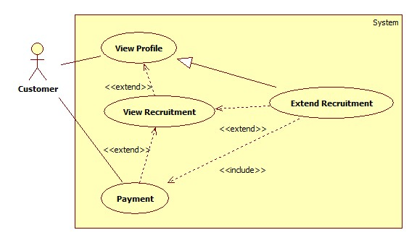

|  |  |  |  |  |
| --- | --- | --- | --- | --- |
| **USE CASE SPECIFICATION** | | | | |
| **Use-case No.** | UC028 | **Use-case Version** | | 1.0 |
| **Use-case Name** | Extend Recruitment | | | |
| **Author** | TuanBT | | | |
| **Date** | 24/09/2014 | **Priority** | High | |
| **Actor:** Customer  **Summary:** …  **Goal:**  …  **Trigger:** …  **Pre-conditions:**   * User must login with Admin role * … page will be shown   **Post conditions:**   * Success: ... * Failure: ….   **Main Success Scenario:**   |  |  | | --- | --- | | Actor Action | System Response | | 1. | 2. |   **Alternative Scenario:**   |  |  | | --- | --- | | Actor Action | System Response | |  |  |   **Exceptions:**   |  |  | | --- | --- | | Actor Action | System Response | | [Exception 1]  1. | 2. |   **Relationships:** N/A  **Business Rules:** N/A | | | | |

##### <Customer> Hide Recruitment

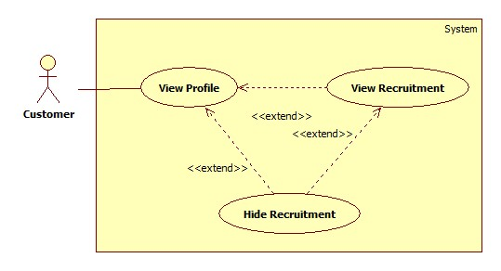

|  |  |  |  |  |
| --- | --- | --- | --- | --- |
| **USE CASE SPECIFICATION** | | | | |
| **Use-case No.** | UC029 | **Use-case Version** | | 1.0 |
| **Use-case Name** | Hide Recruitment | | | |
| **Author** | TuanBT | | | |
| **Date** | 24/09/2014 | **Priority** | High | |
| **Actor:** Customer  **Summary:** …  **Goal:**  …  **Trigger:** …  **Pre-conditions:**   * User must login with Admin role * … page will be shown   **Post conditions:**   * Success: ... * Failure: ….   **Main Success Scenario:**   |  |  | | --- | --- | | Actor Action | System Response | | 1. | 2. |   **Alternative Scenario:**   |  |  | | --- | --- | | Actor Action | System Response | |  |  |   **Exceptions:**   |  |  | | --- | --- | | Actor Action | System Response | | [Exception 1]  1. | 2. |   **Relationships:** N/A  **Business Rules:** N/A | | | | |

##### <Customer> Public Recruitment

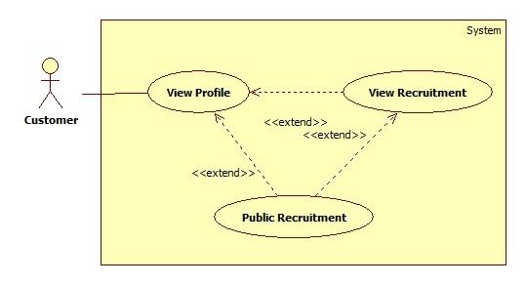

|  |  |  |  |  |
| --- | --- | --- | --- | --- |
| **USE CASE SPECIFICATION** | | | | |
| **Use-case No.** | UC030 | **Use-case Version** | | 1.0 |
| **Use-case Name** | Public Recruitment | | | |
| **Author** | TuanBT | | | |
| **Date** | 24/09/2014 | **Priority** | High | |
| **Actor:** Customer  **Summary:** …  **Goal:**  …  **Trigger:** …  **Pre-conditions:**   * User must login with Admin role * … page will be shown   **Post conditions:**   * Success: ... * Failure: ….   **Main Success Scenario:**   |  |  | | --- | --- | | Actor Action | System Response | | 1. | 2. |   **Alternative Scenario:**   |  |  | | --- | --- | | Actor Action | System Response | |  |  |   **Exceptions:**   |  |  | | --- | --- | | Actor Action | System Response | | [Exception 1]  1. | 2. |   **Relationships:** N/A  **Business Rules:** N/A | | | | |

##### <Customer> Post Recruitment

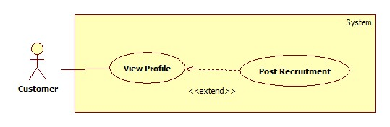

|  |  |  |  |  |
| --- | --- | --- | --- | --- |
| **USE CASE SPECIFICATION** | | | | |
| **Use-case No.** | UC031 | **Use-case Version** | | 1.0 |
| **Use-case Name** | Post Recruitment | | | |
| **Author** | TuanBT | | | |
| **Date** | 24/09/2014 | **Priority** | High | |
| **Actor:** Customer  **Summary:** …  **Goal:**  …  **Trigger:** …  **Pre-conditions:**   * User must login with Admin role * … page will be shown   **Post conditions:**   * Success: ... * Failure: ….   **Main Success Scenario:**   |  |  | | --- | --- | | Actor Action | System Response | | 1. | 2. |   **Alternative Scenario:**   |  |  | | --- | --- | | Actor Action | System Response | |  |  |   **Exceptions:**   |  |  | | --- | --- | | Actor Action | System Response | | [Exception 1]  1. | 2. |   **Relationships:** N/A  **Business Rules:** N/A | | | | |

##### <Customer> Edit Recruitment

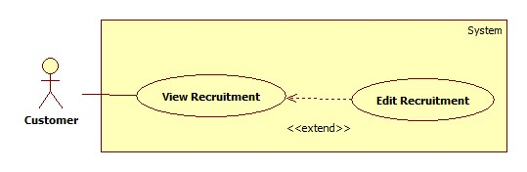

|  |  |  |  |  |
| --- | --- | --- | --- | --- |
| **USE CASE SPECIFICATION** | | | | |
| **Use-case No.** | UC032 | **Use-case Version** | | 1.0 |
| **Use-case Name** | Edit Recruitment | | | |
| **Author** | TuanBT | | | |
| **Date** | 24/09/2014 | **Priority** | High | |
| **Actor:** Customer  **Summary:** …  **Goal:**  …  **Trigger:** …  **Pre-conditions:**   * User must login with Admin role * … page will be shown   **Post conditions:**   * Success: ... * Failure: ….   **Main Success Scenario:**   |  |  | | --- | --- | | Actor Action | System Response | | 1. | 2. |   **Alternative Scenario:**   |  |  | | --- | --- | | Actor Action | System Response | |  |  |   **Exceptions:**   |  |  | | --- | --- | | Actor Action | System Response | | [Exception 1]  1. | 2. |   **Relationships:** N/A  **Business Rules:** N/A | | | | |

##### <Customer> Pay

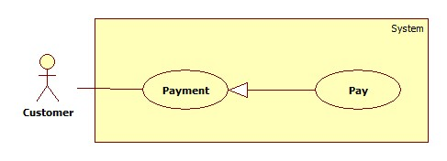

|  |  |  |  |  |
| --- | --- | --- | --- | --- |
| **USE CASE SPECIFICATION** | | | | |
| **Use-case No.** | UC033 | **Use-case Version** | | 1.0 |
| **Use-case Name** | Pay | | | |
| **Author** | TuanBT | | | |
| **Date** | 24/09/2014 | **Priority** | High | |
| **Actor:** Customer  **Summary:** Customer will pay online by Paypal for them Recruitment.  **Goal:**  Pay online by Paypal.  **Trigger:** Post success a Recruitment.  **Pre-conditions:**   * User must login with Admin role * Paypal button will be shown   **Post conditions:**   * Success: Status of Recruitment change to Watting mean “Đang chờ người làm”. * Failure: Button Paypal not hide.   **Main Success Scenario:**   |  |  | | --- | --- | | Actor Action | System Response | | 1. Click Paypal button.  3. Do pay money. | 2. System redirect to Paypal Page.  4. Button Paypal hide, status of Recruitment change to “Đang chờ người làm”.  [Exception 1] |   **Alternative Scenario:**   |  |  | | --- | --- | | Actor Action | System Response | | [Alternative 1]  1. Customer click a Recruitment form “Hết hạn” tab in Profile page. Then Click “Gia hạn” button.  3. Click Paypal button.  5. Do pay money.  [Alternative 2]  1. Customer click title a Recruitment from “Hết hạn” tab in Profile page.  3. Click “Gia hạn” button.  5. Do pay money. | 2. System show “Gia hạn đơn tuyển việc” modal.  4. System redirect to Paypal page.  6. Button Paypal hide, status of Recruitment change to “Đang chờ người làm”.  [Exception 1]  2. System redirect to “Tin tìm người giúp việc” page.  4. System redirect to Paypal page.  6. Button Paypal hide, status of Recruitment change to “Đang chờ người làm”.  [Exception 1] |   **Exceptions:**   |  |  | | --- | --- | | Actor Action | System Response | | [Exception 1]  1. Paypal page not return MS-Website. | 2. Paypal button not Hide. |   **Relationships:** Pay is generalization Payment  **Business Rules:** Recruitment must have paypal account to pay. If the payment process is not successful because whatever resons is, Customer can click “Ấn vào đây” in “Nếu bạn đã thanh toán?” Box in “Tin tìm người giúp việc” page, to contact Staff. After that, Staff must go to website to check if that Recruitment is paid or not. If it is paid, Staff goes to management page to active this Recruitment. | | | | |

##### <Customer> View Customer Statistic

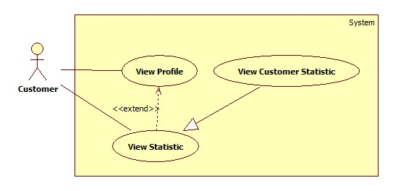

|  |  |  |  |  |
| --- | --- | --- | --- | --- |
| **USE CASE SPECIFICATION** | | | | |
| **Use-case No.** | UC034 | **Use-case Version** | | 1.0 |
| **Use-case Name** | View Customer Statistic | | | |
| **Author** | TuanBT | | | |
| **Date** | 24/09/2014 | **Priority** | High | |
| **Actor:** Customer  **Summary:** …  **Goal:**  …  **Trigger:** …  **Pre-conditions:**   * User must login with Admin role * … page will be shown   **Post conditions:**   * Success: ... * Failure: ….   **Main Success Scenario:**   |  |  | | --- | --- | | Actor Action | System Response | | 1. | 2. |   **Alternative Scenario:**   |  |  | | --- | --- | | Actor Action | System Response | |  |  |   **Exceptions:**   |  |  | | --- | --- | | Actor Action | System Response | | [Exception 1]  1. | 2. |   **Relationships:** N/A  **Business Rules:** N/A | | | | |

##### <Staff, Maid Mediator> Manage Maid

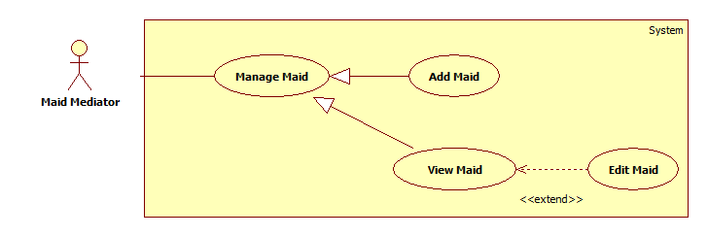

###### **<Staff, Maid Mediator> Add Maid**

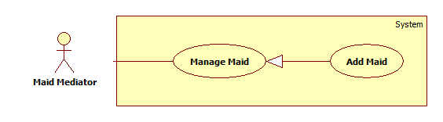

|  |  |  |  |  |
| --- | --- | --- | --- | --- |
| **USE CASE SPECIFICATION** | | | | |
| **Use-case No.** | UC035 | **Use-case Version** | | 1.0 |
| **Use-case Name** | Add maid | | | |
| **Author** | TuyenMQ | | | |
| **Date** | 21/09/2014 | **Priority** | High | |
| **Actor:** Staff, Maid Mediator  **Summary:** This use case allow maid mediator or staff to add maid for management.  **Goal:** Maid mediator orstaff can add maid  **Trigger:** User clicks button “Thêm người giúp việc” at the top of maids list in profile page  **Pre-conditions:**   * Page is loaded successfully * User login as maid mediator or staff successful   **Post conditions:**   * Success: Add maid successfully, new maid is added to database * Failure: Show error message   **Main Success Scenario:**   |  |  | | --- | --- | | Actor Action | System Response | | 1. Login as a maid mediator or staff 2. Click name link 3. Click “Thêm người giúp việc” button 4. Fill all the fields 5. Click “Hoàn tất thêm người giúp việc” button | 1. System redirects to home page 2. System redirects to personal profile page 3. System redirects to add maid page with following fields:  * Họ và tên [MaidName: textbox] * Kinh nghiệm [Experience: dropdownlist] * Số điện thoại [Phone: textbox] * Ngày sinh [BirthDate: textbox] * Giới tính [Gender: dropdownlist] * Biết tiếng [LanguageEnglish: checkbox, LanguageChina: checkbox, LanguageJapanese: checkbox, LanguageKorean: checkbox] * Nguyên quán [Hometown: dropdownlist] * Đang sống tại [Address: dropdownlist] * Kết hôn [Married: dropdownlist] * Giới thiệu bản thân [Description: textbox] * “Hoàn tất thêm người giúp việc” button.  1. System redirects to personal profile page |   **Alternative Scenario:**   |  |  | | --- | --- | | Actor Action | System Response | | 1. Click on the “Đăng xuất” button. | 1. Clear session and back to homepage |   **Exceptions:**   |  |  | | --- | --- | | Actor Action | System Response | | 1. “Họ và tên” is empty 2. “Số điện thoại” is empty or not a numberic value 3. “Ngày sinh” is empty | 1. Show message “Vui lòng nhập tên người giúp việc” 2. Show message “Vui lòng nhập số” 3. Show message “Vui lòng chọn ngày sinh” |   **Relationships:** Is a generalization of Manage Maid  **Business Rules:** This use caseis only available for maid mediator and staff, so user must log in as one of these two roles. After logging in, user clicks the name link to go to personal profile page and there is a list of maids whom the user is managing. User click “Thêm người giúp việc” button on the top of the list to add a new maid to manage. System redirects to maid creating page with fields requiring user’s inputs to complete the info of the new maid. There are 3 mandatory fields: “Họ và tên”, “Số điện thoại”, “Ngày sinh” so user must not let these fields empty or the error message is shown. After filling all the info field, user can click “Hoàn tất thêm người giúp việc” button to complete the maid adding process. After that, the system redirects back to personal profile page and the new added maid will be displayed at the bottom of the maids list. | | | | |

###### **<Authenticated user> View Maid**

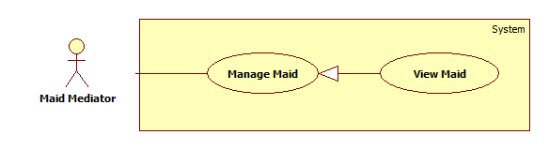

|  |  |  |  |  |
| --- | --- | --- | --- | --- |
| **USE CASE SPECIFICATION** | | | | |
| **Use-case No.** | UC036 | **Use-case Version** | | 1.0 |
| **Use-case Name** | View maid | | | |
| **Author** | TuyenMQ | | | |
| **Date** | 21/09/2014 | **Priority** | High | |
| **Actor:** Authenticated user (Staff, Maid Mediator, Customer, Admin)  **Summary:** This use case allow logged user to view a maid’s detail.  **Goal:** User can view a maid’s detail.  **Trigger:** User clicks the name link of a maid.  **Pre-conditions:**   * Page is loaded successfully * User login successfully   **Post conditions:**   * Success: Maid detail page is displayed * Failure: Show error message   **Main Success Scenario:**   |  |  | | --- | --- | | Actor Action | System Response | | 1. Login as Staff 2. Click the name link 3. Click a maid name in maids list | 1. System redirects to personal page 2. System redirects to maid profile page |   **Alternative Scenario:**   |  |  | | --- | --- | | Actor Action | System Response | | 1. Click on the “Đăng xuất” button. | 1. Clear session and back to homepage |   **Exceptions:**   |  |  | | --- | --- | | Actor Action | System Response | | 1. Maid does not exist | 1. Show error message |   **Relationships:** Is a generalization of Manage Maid  **Business Rules:** This use caseis available for any role except guest, so user must log in to view a maid’s detail. As customer, user can search a job request or go to personal profile page and click on a job request in recommended list of a “Waiting” recruitment or in tab “Đã thuê” to go to job request detail page. There is a name link of a maid whom the job request belongs to, click on that link to go to maid detail page which displays the info of that maid. As admin, user can only search a job request and then do the same as customer. As staff or maid mediator, just simply click on a maid name link in the maids list. | | | | |

###### **<Staff, Maid Mediator> Edit Maid**

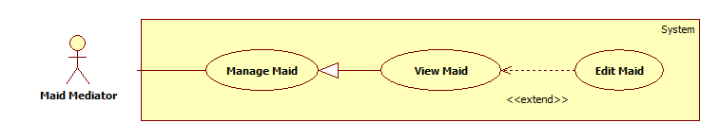

|  |  |  |  |  |
| --- | --- | --- | --- | --- |
| **USE CASE SPECIFICATION** | | | | |
| **Use-case No.** | UC037 | **Use-case Version** | | 1.0 |
| **Use-case Name** | Edit maid | | | |
| **Author** | TuyenMQ | | | |
| **Date** | 21/09/2014 | **Priority** | High | |
| **Actor:** Staff, Maid Mediator  **Summary:** This use case allow staff edit a maid’s info  **Goal:** User can edit info of a maid  **Trigger:** User clicks “Sửa thông tin người giúp việc” link in maid profile page  **Pre-conditions:**   * Page is loaded successfully * User login as staff or maid mediator successful   **Post conditions:**   * Success: Edit maid’s info successfully and save to database * Failure: Show error message   **Main Success Scenario:**   |  |  | | --- | --- | | Actor Action | System Response | | 1. Login as a staff or maid mediator 2. Click name link 3. Click maid name link in maids list 4. Click “Sửa thông tin người giúp việc” link 5. Fill all the field 6. Click “Cập nhật thông tin” button | 1. System redirect home page 2. System redirect personal profile page 3. System redirect maid profile page 4. System redirect add maid page with following fields which displays the maid’s info accordingly:  * Họ và tên [MaidName: textbox] * Kinh nghiệm [Experience: dropdownlist] * Số điện thoại [Phone: textbox] * Ngày sinh [BirthDate: textbox] * Giới tính [Gender: dropdownlist] * Biết tiếng [LanguageEnglish: checkbox, LanguageChina: checkbox, LanguageJapanese: checkbox, LanguageKorean: checkbox] * Nguyên quán [Hometown: dropdownlist] * Đang sống tại [Address: dropdownlist] * Kết hôn [Married: dropdownlist] * Giới thiệu bản thân [Description: textbox] * Ảnh đại diện [Image uploading] * “Cập nhật thông tin” button.  1. System redirects to maid profile page |   **Alternative Scenario:**   |  |  | | --- | --- | | Actor Action | System Response | | 1. Click on the “Đăng xuất” button. | 1. Clear session and back to home page |   **Exceptions:**   |  |  | | --- | --- | | Actor Action | System Response | | 1. “Họ và tên” is empty 2. “Số điện thoại” is empty or not a numberic value 3. “Ngày sinh” is empty | 1. Show message “Vui lòng nhập tên người giúp việc” 2. Show message “Vui lòng nhập số” 3. Show message “Vui lòng chọn ngày sinh” |   **Relationships:** Is an extension of View Maid  **Business Rules:** This use caseis only available for maid mediator and staff, so user must log in as one of these two roles. After logging in, user clicks the name link to go to personal profile page and there is a list of maids whom the user is managing. Click a maid name to go to maid profile page. Click on the “Sửa thông tin người giúp việc” link to go to maid editing page displaying fields with the info of that maid for editing. User can edit those info then click “Cập nhật thông tin” button to complete editing process. The system redirects to the edited maid’s profile page and the all info are updated. | | | | |

##### <Staff, Maid Mediator> Public Job Request

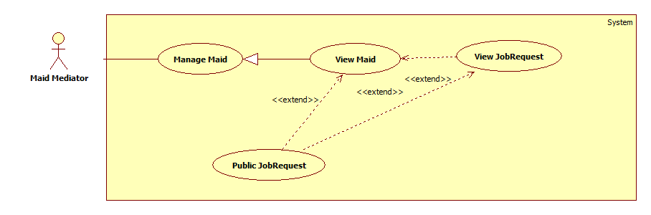

|  |  |  |  |  |
| --- | --- | --- | --- | --- |
| **USE CASE SPECIFICATION** | | | | |
| **Use-case No.** | UC038 | **Use-case Version** | | 1.0 |
| **Use-case Name** | Public Job Request | | | |
| **Author** | TuyenMQ | | | |
| **Date** | 21/09/2014 | **Priority** | High | |
| **Actor:** Staff, Maid Mediator  **Summary:** This use case allow staff or maid mediator to public a job request for customer to apply  **Goal:** User can public a job request  **Trigger:** User clicks “Công khai” button  **Pre-conditions:**   * Page is loaded successfully * User login as staff or maid mediator successfully   **Post conditions:**   * Success: Public job request successfully, status of job request is changed from “Hide” to “Waiting” * Failure: Show error message   **Main Success Scenario:**   |  |  | | --- | --- | | Actor Action | System Response | | 1. Login as a staff or maid mediator 2. Click name link 3. Click a job request in tab “Tạm ẩn” 4. Click “Công khai” button | 1. System redirect home page 2. System redirect personal profile page 3. System redirects to job request detail page and displays “Tình trạng: Đang chờ” |   **Alternative Scenario:**   |  |  | | --- | --- | | Actor Action | System Response | | 1. Click on the “Đăng xuất” button. | 1. Clear session and back to home page |   **Exceptions:**   |  |  | | --- | --- | | Actor Action | System Response | | 1. Job request does not exist | 1. Show error message |   **Relationships:** Is an extension of View Maid and View Job Request  **Business Rules:** This use caseis only available for maid mediator and staff, so user must log in as one of these two roles. After logging in, user clicks the name link to go to personal profile page and there is a list of maids whom the user is managing. Click a maid name to go to maid profile page. There are five tabs which represent five statuses of job request. In “Tạm ẩn” tab which only contains job request with “Hide” status in database, user can click on a job request (not job request’s name link) then the button “Công khai” will be displayed, user can also click on job request’s name link to go to job request detail page and the button “Công khai” will be displayed too. Be noticed that only job requests in “Tạm ẩn” tab (with status “Hide” in database) have this function. User clicks “Công khai” button to public the job request, the status of the job request will be changed from “Hide” to “Waiting” in database and it’s also moved to “Đang chờ” tab in maid profile page. Now the job request is ready for customers to apply. | | | | |

##### <Staff, Maid Mediator> Hide Job Request

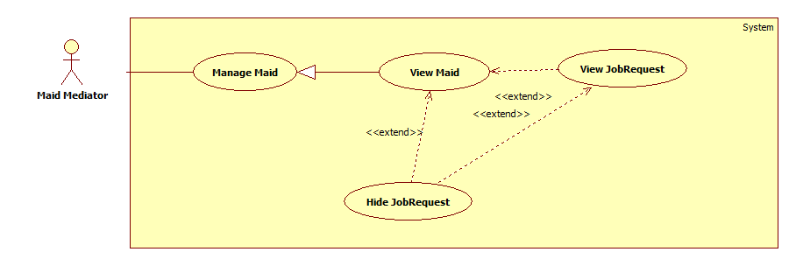

|  |  |  |  |  |
| --- | --- | --- | --- | --- |
| **USE CASE SPECIFICATION** | | | | |
| **Use-case No.** | UC039 | **Use-case Version** | | 1.0 |
| **Use-case Name** | Hide Job Request | | | |
| **Author** | TuyenMQ | | | |
| **Date** | 21/09/2014 | **Priority** | High | |
| **Actor:** Staff, Maid Mediator  **Summary:** This use case allow staff or maid mediator to hide a job request and can’t be applied by any customer  **Goal:** User can hide a job request  **Trigger:** User clicks “Tạm ẩn” button  **Pre-conditions:**   * Page is loaded successfully * User login as staff or maid mediator successfully   **Post conditions:**   * Success: Hide job request successfully, status of job request is changed from “Waiting” to “Hide” * Failure: Show error message   **Main Success Scenario:**   |  |  | | --- | --- | | Actor Action | System Response | | 1. Login as a staff or maid mediator 2. Click name link 3. Click a job request in tab “Đang chờ” 4. Click “Tạm ẩn” button | 1. System redirect home page 2. System redirect personal profile page 3. System redirects to job request detail page and displays “Tình trạng: Tạm ẩn” |   **Alternative Scenario:**   |  |  | | --- | --- | | Actor Action | System Response | | 1. Click on the “Đăng xuất” button. | 1. Clear session and back to home page |   **Exceptions:**   |  |  | | --- | --- | | Actor Action | System Response | | 1. Job request does not exist | 1. Show error message |   **Relationships:** Is an extension of View Maid and View Job Request  **Business Rules:** This use caseis only available for maid mediator and staff, so user must log in as one of these two roles. After logging in, user clicks the name link to go to personal profile page and there is a list of maids whom the user is managing. Click a maid name to go to maid profile page. There are five tabs which represent five statuses of job request. In “Đang chờ” tab which only contains job request with “Waiting” status in database, user can click on a job request (not job request’s name link) then the button “Tạm ẩn” will be displayed, user can also click on job request’s name link to go to job request detail page and the button “Tạm ẩn” will be displayed too. Be noticed that only job requests in “Đang chờ” tab (with status “Waiting” in database) have this function. User clicks “Tạm ẩn” button to hide the job request, the status of the job request will be changed from “Waiting” to “Hide” in database and it’s also moved to “Tạm ẩn” tab in maid profile page. Now the job request can’t be applied. | | | | |

##### <Staff, MaidMediator> Extend Job Request

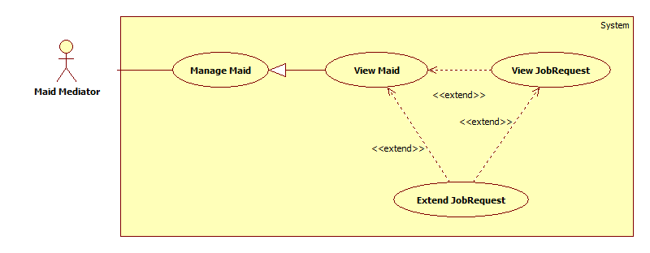

|  |  |  |  |  |
| --- | --- | --- | --- | --- |
| **USE CASE SPECIFICATION** | | | | |
| **Use-case No.** | UC040 | **Use-case Version** | | 1.0 |
| **Use-case Name** | Extend Job Request | | | |
| **Author** | TuyenMQ | | | |
| **Date** | 21/09/2014 | **Priority** | High | |
| **Actor:** Staff, Maid Mediator  **Summary:** This use case allow staff or maid mediator to extend job request  **Goal:** Staff or maid mediator can extend job request  **Trigger:** User clicks “Gia hạn” button  **Pre-conditions:**   * Page is loaded successfully * User login as staff or maid mediator successful   **Post conditions:**   * Success: Extend job request successfully, job request’s expired date is updated in database and status changes from “Expired” to “Waiting” * Failure: Show error message   **Main Success Scenario:**   |  |  | | --- | --- | | Actor Action | System Response | | 1. Login as a staff or maid mediator 2. Click the name link 3. Click a maid name link in maids list 4. Choose a job request in any tab except “Được nhận” and “Hoàn tất” tabs 5. Click “Gia hạn” button 6. Click “Đồng ý” button | 1. System redirects to homepage 2. System redirects to personal profile page 3. System redirects to maid profile page 4. A modal pops up with a dropdown list for user to choose the extending time 5. System redirects to extended job request’s detail page |   **Alternative Scenario:**   |  |  | | --- | --- | | Actor Action | System Response | | 1. Click on the “Đăng xuất” button. | 1. Clear session and back to home page |   **Exceptions:**   |  |  | | --- | --- | | Actor Action | System Response | | 1. Job request was applied | 1. Show alert message “Công việc đã được thuê” |   **Relationships:** Is an extension of View Profile  **Business Rules:** This use caseis only available for maid mediator and staff, so user must log in as one of these two roles. After logging in, user clicks the name link to go to personal profile page. User clicks a maid name link in the maids list to go to maid profile list. User choose a job request from any tab except “Được nhận” and “Hoàn tất” tabs then click “Gia hạn” button which appears afterward. A modal pops up and user choose the extending time from the dropdown list then click “Đồng ý” button to complete the process. Job request’s expired time is updated and status changes from “Expired” (if job request’s status is “Expired”) to “Waiting” in database. The system redirects to that job request’s detail page and the extended job request moves from “Hết hạn” tab to “Đang chờ” tab in maid profile page. | | | | |

##### <Staff, MaidMediator> Edit JobRequest

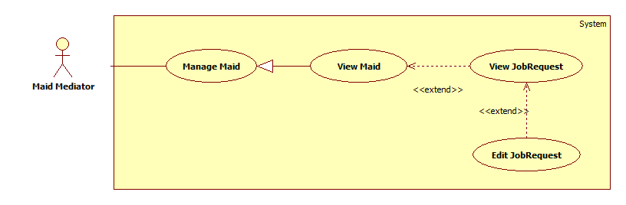

|  |  |  |  |  |
| --- | --- | --- | --- | --- |
| **USE CASE SPECIFICATION** | | | | |
| **Use-case No.** | UC041 | **Use-case Version** | | 1.0 |
| **Use-case Name** | Edit JobRequest | | | |
| **Author** | TuyenMQ | | | |
| **Date** | 21/09/2014 | **Priority** | High | |
| **Actor:** Staff, Maid Mediator  **Summary:** This use case allow staff or maid mediator to edit job request  **Goal:** Staff or maid mediator can edit job request  **Trigger:** User click “Sửa yêu cầu công việc” link in job request detail page  **Pre-conditions:**   * Page is loaded successfully * User login as staff or maid mediator successful   **Post conditions:**   * Success: Edit job request successfully, job request’s detail and skill reference’s detail are updated in database * Failure: Show error message   **Main Success Scenario:**   |  |  | | --- | --- | | Actor Action | System Response | | 1. Login as a staff or maid mediator 2. Click the name link 3. Click a maid name link in maids list 4. Click a job request link in “Chưa kích hoạt” tab 5. Click “Sửa thông tin yêu cầu công việc” link 6. Fill all the fields 7. Click “Sửa yêu cầu” button | 1. System redirects to homepage 2. System redirects to personal profile page 3. System redirects to job request detail page 4. System redirects to job request editing page displaying following fields with info of the job request accordingly:  * Đăng cho [MaidName: textbox] * Tiêu đề [Title: dropdownlist] * Các kỹ năng [SkillRefId: textbox] * “Sửa yêu cầu” button  1. System redirects to edited job request’s detail page |   **Alternative Scenario:**   |  |  | | --- | --- | | Actor Action | System Response | | 1. Click on the “Đăng xuất” button. | 1. Clear session and back to home page |   **Exceptions:**   |  |  | | --- | --- | | Actor Action | System Response | | 1. Job request is active 2. “Đăng cho” is empty 3. “Tiêu đề” is empty 4. “Các kỹ năng” is empty | 1. Show alert message “Công việc đã hết hạn cho sửa” 2. Show message “Vui lòng chọn người giúp việc” 3. Show message “Vui lòng nhập tiêu đề” 4. Show message “Vui lòng chọn kĩ năng” |   **Relationships:** Is an extension of View Job Request  **Business Rules:** This use caseis only available for maid mediator and staff, so user must log in as one of these two roles. After logging in, user clicks the name link to go to personal profile page. User clicks on a maid name link in maids list to go to maid profile page. In “Chưa kích hoạt” tab click a job request link to go to job request detail page. Click “Sửa thông tin yêu cầu tìm việc” link to go to job request editing page. User edit the info then click “Sửa yêu cầu” button to complete the editing process. Only inactive job requests have this function, so if the user click “Sửa thông tin yêu cầu tìm việc” link of active job requests, the alert message “Công việc đã hết hạn cho sửa” will be displayed. | | | | |

##### <Staff, MaidMediator> Edit Maid Mediator Profile

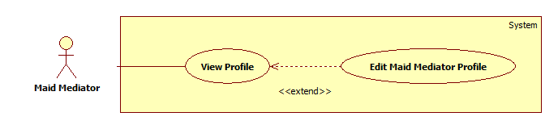

|  |  |  |  |  |
| --- | --- | --- | --- | --- |
| **USE CASE SPECIFICATION** | | | | |
| **Use-case No.** | UC042 | **Use-case Version** | | 1.0 |
| **Use-case Name** | Edit Maid Mediator Profile | | | |
| **Author** | TuyenMQ | | | |
| **Date** | 21/09/2014 | **Priority** | High | |
| **Actor:** Staff, Maid Mediator  **Summary:** This use case allow staff or maid mediator to edit profile  **Goal:** Staff or maid mediator can edit profile  **Trigger:** User clicks “Sửa thông tin cá nhân” link in personal profile page  **Pre-conditions:**   * Page is loaded successfully * User login as staff or maid mediator successful   **Post conditions:**   * Success: Edit profile successfully, profile detail is updated in database * Failure: Show error message   **Main Success Scenario:**   |  |  | | --- | --- | | Actor Action | System Response | | 1. Login as a staff or maid mediator 2. Click the name link 3. Click “Sửa thông tin cá nhân” link 4. Fill all the fields 5. Click “Cập nhật thông tin” button | 1. System redirects to homepage 2. System redirects to personal profile page 3. System redirects to profile editing page displaying following fields with info of the job request accordingly:  * Họ và tên [FullName: textbox] * Số điện thoại [Phone: textbox] * Email [Email: textbox] * Ảnh đại diện [Image uploading] * “Cập nhật thông tin” button  1. System redirects to personal profile page with updated info |   **Alternative Scenario:**   |  |  | | --- | --- | | Actor Action | System Response | | 1. Click on the “Đăng xuất” button. | 1. Clear session and back to home page |   **Exceptions:**   |  |  | | --- | --- | | Actor Action | System Response | | 1. “Họ và tên” is empty 2. “Số điện thoại” is empty or char inputted 3. “Email” is empty or wrong format | 1. Show message “Vui lòng nhập tên người quản lý” 2. Show message “Vui lòng nhập số” 3. Show message “Vui lòng nhập đúng định dạng abc@abc.ab” |   **Relationships:** Is an extension of View Profile  **Business Rules:** This use caseis only available for maid mediator and staff since staff is also a maid mediator, so user must log in as one of these two roles. After logging in, user clicks the name link to go to personal profile page. User clicks “Sửa thông tin cá nhân” link to go to profile editing page. User edit the info then click “Cập nhật thông tin” button to complete the editing process. Data is updated in database, system redirects back to personal profile page and the info are updated. | | | | |

##### <Staff, MaidMediator> Post JobRequest

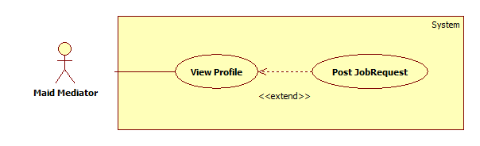

|  |  |  |  |  |
| --- | --- | --- | --- | --- |
| **USE CASE SPECIFICATION** | | | | |
| **Use-case No.** | UC043 | **Use-case Version** | | 1.0 |
| **Use-case Name** | Post JobRequest | | | |
| **Author** | TuyenMQ | | | |
| **Date** | 21/09/2014 | **Priority** | High | |
| **Actor:** Staff, Maid Mediator  **Summary:** This use case allow staff or maid mediator to post job request  **Goal:** Staff or maid mediator can post job request  **Trigger:** User clicks “Đăng yêu cầu tìm việc” link in personal profile page  **Pre-conditions:**   * Page is loaded successfully * User login as staff or maid mediator successful   **Post conditions:**   * Success: Post job request successfully, new job request and skill reference are added to database * Failure: Show error message   **Main Success Scenario:**   |  |  | | --- | --- | | Actor Action | System Response | | 1. Login as a staff or maid mediator 2. Click the name link 3. Click “Đăng yêu cầu công việc” link 4. Fill all the fields 5. Click “Đăng yêu cầu” button | 1. System redirects to homepage 2. System redirects to personal profile page 3. System redirect post jobrequest page with following fields:  * Đăng cho [MaidName: textbox] * Tiêu đề [Title: dropdownlist] * Các kỹ năng [SkillRefId: textbox] * Thời hạn đăng [PostTime: textbox] * “Đăng yêu cầu” button  1. System redirects to new job request’s detail page |   **Alternative Scenario:**   |  |  | | --- | --- | | Actor Action | System Response | | 1. Click on the “Đăng xuất” button. | 1. Clear session and back to home page |   **Exceptions:**   |  |  | | --- | --- | | Actor Action | System Response | | 1. “Đăng cho” is empty 2. “Tiêu đề” is empty 3. “Các kỹ năng” is empty | 1. Show message “Vui lòng chọn người giúp việc” 2. Show message “Vui lòng nhập tiêu đề” 3. Show message “Vui lòng chọn kĩ năng” |   **Relationships:** Is an extension of View Profile  **Business Rules:** This use caseis only available for maid mediator and staff, so user must log in as one of these two roles. After logging in, user clicks the name link to go to personal profile page. User clicks on “Đăng yêu cầu công việc” link to go to request adding page which displays all required fields for a job request to be created. There are 3 mandatory fields: “Đăng cho” (User must choose a maid from the managed maids list to post this job request for that maid), “Tiêu đề”, “Các kĩ năng” (User must choose at least a skill from the skills list). After completing all the fields, user can click “Đăng yêu cầu” button to complete posting a new job request. New job request is added to JobRequest table and new skill reference is added to SkillReference table in database. The system redirects to new added job request’s detail page. | | | | |

##### <Staff, MaidMediator> View Maid Manager Statistic

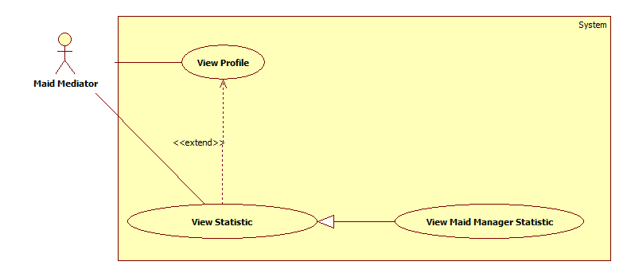

|  |  |  |  |  |
| --- | --- | --- | --- | --- |
| **USE CASE SPECIFICATION** | | | | |
| **Use-case No.** | UC047 | **Use-case Version** | | 1.0 |
| **Use-case Name** | View Maid Manager Statistic | | | |
| **Author** | TuyenMQ | | | |
| **Date** | 21/09/2014 | **Priority** | High | |
| **Actor:** Staff, Maid Mediator  **Summary:** This use case allow staff or maid mediator to view personal statistic as maid mediator  **Goal:** Staff or maid mediator can view personal statistic  **Trigger:** User clicks “Thống kê” link in personal profile page  **Pre-conditions:**   * Page is loaded successfully * User login as staff or maid mediator successful   **Post conditions:**   * Success: Personal Statistic page is loaded successfully * Failure: Show error message   **Main Success Scenario:**   |  |  | | --- | --- | | Actor Action | System Response | | 1. Login as a staff or maid mediator 2. Click the name link 3. Click “Thống kê” link | 1. System redirects to homepage 2. System redirects to personal profile page 3. System redirects to personal statistic page |   **Alternative Scenario:**   |  |  | | --- | --- | | Actor Action | System Response | | 1. Click on the “Đăng xuất” button. | 1. Clear session and back to home page |   **Exceptions:**   |  |  | | --- | --- | | Actor Action | System Response | | 1. User hasn’t posted any job request | 1. The statistic diagram is not displayed |   **Relationships:** Is a generalization of View Statistic  **Business Rules:** This use caseis only available for maid mediator and staff, so user must log in as one of these two roles. After logging in, user clicks the name link to go to personal profile page. User clicks “Thống kê” link to go to personal statistic page. The statistic circle diagram is displayed and is divided into parts according to the number of job requests of each status (Each status has one color). When user moves the mouse to a part of he diagram, the number of job requests of that status will be displayed. If the user hasn’t post any job request yet, the diagram will not appear. | | | | |

##### <Webmaster> Manage Number of Kmean

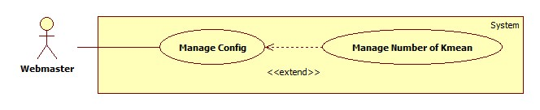

|  |  |  |  |  |
| --- | --- | --- | --- | --- |
| **USE CASE SPECIFICATION** | | | | |
| **Use-case No.** | UC048 | **Use-case Version** | | 1.0 |
| **Use-case Name** | Manage Number of Kmean | | | |
| **Author** | TuanBT | | | |
| **Date** | 24/09/2014 | **Priority** | High | |
| **Actor:** Webmaster  **Summary:** Change number K of Kmean algorithm. K same number of group.  **Goal:**  Change value.  **Trigger:** Webmaster click “Quản lý cấu hình”  **Pre-conditions:**   * User must login with Admin role * Manage config page will be shown   **Post conditions:**   * Success: Reload page and change value. * Failure: Show error.   **Main Success Scenario:**   |  |  | | --- | --- | | Actor Action | System Response | | 1. Webmaster click “Quản lý cấu hình” menu, then fill input “Gợi ý số K” | 2. Show notification “Cập nhập số K thành công.”.  [Exception 1] |   **Alternative Scenario:**   |  |  | | --- | --- | | Actor Action | System Response | |  |  |   **Exceptions:**   |  |  | | --- | --- | | Actor Action | System Response | | [Exception 1]  1. Fill input not a digit. | 2. Show error “Phải nhập số nguyên!” |   **Relationships:** Manage Number of Kmean is extend of Manage config.  **Business Rules:** Number of K must smaller than total of Jobrequest or Recruitment. | | | | |

##### <Webmaster> Manage Number Of Weeks

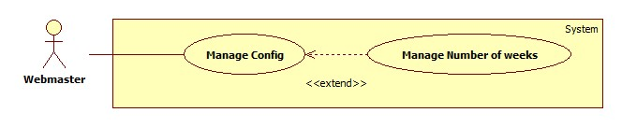

|  |  |  |  |  |
| --- | --- | --- | --- | --- |
| **USE CASE SPECIFICATION** | | | | |
| **Use-case No.** | UC049 | **Use-case Version** | | 1.0 |
| **Use-case Name** | Manage Number of weeks | | | |
| **Author** | TuanBT | | | |
| **Date** | 24/09/2014 | **Priority** | High | |
| **Actor:** Webmaster  **Summary:** Change maximum week when user post a JoRequest or Recruiment in to MS-Website.  **Goal:**  Change value.  **Trigger:** Webmaster click “Quản lý cấu hình”  **Pre-conditions:**   * User must login with Admin role * Manage config page will be shown   **Post conditions:**   * Success: Reload page and change value. * Failure: Show error.   **Main Success Scenario:**   |  |  | | --- | --- | | Actor Action | System Response | | 1. Webmaster click “Quản lý cấu hình” menu, then fill input “Số mới” | 2. Show notification “Cập nhập số tuần thành công.”  [Exception 1] |   **Alternative Scenario:**   |  |  | | --- | --- | | Actor Action | System Response | |  |  |   **Exceptions:**   |  |  | | --- | --- | | Actor Action | System Response | | [Exception 1]  1. Fill input not a digit. | 2. Show error “Phải nhập số nguyên!” |   **Relationships:** Manage Number of weeks is extend of Manage config.  **Business Rules:** Webmaster must enter an integer number. | | | | |
|  | | | | |

##### <Webmaster> Manage JobRequest Price

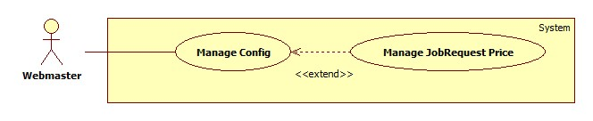

|  |  |  |  |  |
| --- | --- | --- | --- | --- |
| **USE CASE SPECIFICATION** | | | | |
| **Use-case No.** | UC050 | **Use-case Version** | | 1.0 |
| **Use-case Name** | Manage JobRequest Price | | | |
| **Author** | TuanBT | | | |
| **Date** | 24/09/2014 | **Priority** | High | |
| **Actor:** Webmaster  **Summary:** Change price when a new JobRequest post to MS-Website.  **Goal:**  Change value.  **Trigger:** Webmaster click “Quản lý cấu hình”  **Pre-conditions:**   * User must login with Admin role * Manage config page will be shown   **Post conditions:**   * Success: Reload page and change value. * Failure: Show error.   **Main Success Scenario:**   |  |  | | --- | --- | | Actor Action | System Response | | 1. Webmaster click “Quản lý cấu hình” menu, then fill input “Giá mới” | 2. Show notification “Cập nhập đơn giá cho yêu cầu công việc thành công.”  [Exception 1] |   **Alternative Scenario:**   |  |  | | --- | --- | | Actor Action | System Response | |  |  |   **Exceptions:**   |  |  | | --- | --- | | Actor Action | System Response | | [Exception 1]  1. Fill input not a digit. | 2. Show error “Phải nhập số nguyên!” |   **Relationships:** Manage JobRequest Price is extend of Manage config.  **Business Rules:** Webmaster must enter a integer number. | | | | |

##### <Webmaster> Manage Recruitment Price

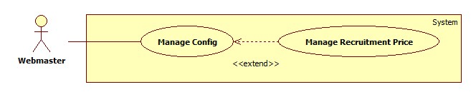

|  |  |  |  |  |
| --- | --- | --- | --- | --- |
| **USE CASE SPECIFICATION** | | | | |
| **Use-case No.** | UC051 | **Use-case Version** | | 1.0 |
| **Use-case Name** | Manage Recruitment Price | | | |
| **Author** | TuanBT | | | |
| **Date** | 24/09/2014 | **Priority** | High | |
| **Actor:** Webmaster  **Summary:** Change price when a new Recruitment post to MS-Website.  **Goal:**  Change value.  **Trigger:** Webmaster click “Quản lý cấu hình”  **Pre-conditions:**   * User must login with Admin role * Manage config page will be shown   **Post conditions:**   * Success: Reload page and change value. * Failure: Show error.   **Main Success Scenario:**   |  |  | | --- | --- | | Actor Action | System Response | | 1. Webmaster click “Quản lý cấu hình” menu, then fill input “Giá mới” | 2. Show notification “Cập nhập đơn giá cho yêu cầu tìm người thành công.”  [Exception 1] |   **Alternative Scenario:**   |  |  | | --- | --- | | Actor Action | System Response | |  |  |   **Exceptions:**   |  |  | | --- | --- | | Actor Action | System Response | | [Exception 1]  1. Fill input not a digit. | 2. Show error “Phải nhập số nguyên!” |   **Relationships:** Manage Recruitment Price is extend of Manage config.  **Business Rules:** Webmaster must enter a integer number. | | | | |

##### <Staff> Manage JobRequest and Recruitment

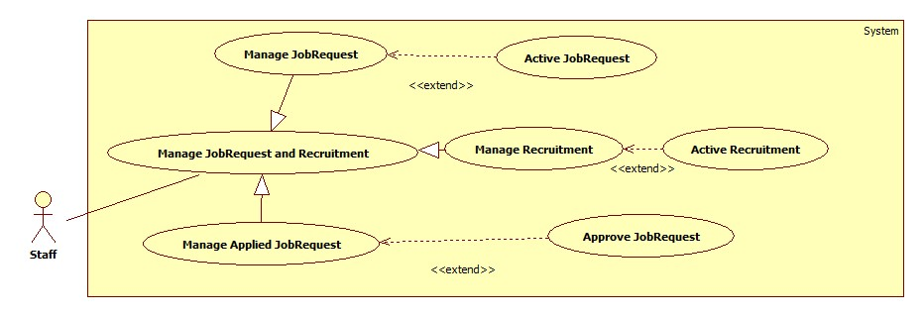

###### **<Staff> Active JobRequest**

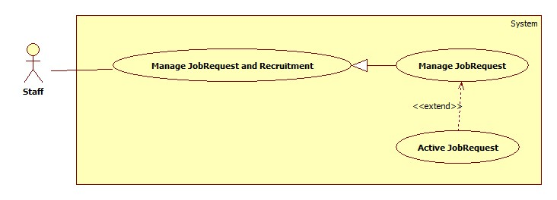

|  |  |  |  |  |
| --- | --- | --- | --- | --- |
| **USE CASE SPECIFICATION** | | | | |
| **Use-case No.** | UC044 | **Use-case Version** | | 1.0 |
| **Use-case Name** | Active JobRequest | | | |
| **Author** | CongNT | | | |
| **Date** | 21/09/2014 | **Priority** | High | |
| **Actor:** Staff  **Summary:** This use case allow staff to active job request to public it on website  **Goal:** Staff can allow job request to public on website  **Trigger:** User choose a job request then click “Chấp nhận” button  **Pre-conditions:**   * Page is loaded successfully * User login as staff successful   **Post conditions:**   * Success: Login successfully, the job request will be allowed to public on website * Failure:   **Main Success Scenario:**   |  |  | | --- | --- | | Actor Action | System Response | | 1. Login as a staff 2. Choose a job request, click “Kích hoạt” button 3. Click “Chấp nhận” button. | 1. System redirect to list of job request 2. System show a “Xác nhận kích hoạt” pop up. 3. Change IsActive(false) to IsActive(true) and save change to database |   **Alternative Scenario:**   |  |  | | --- | --- | | Actor Action | System Response | | 1. Click on the “Đăng xuất” button. | 1. Clear session and back to home page |   **Exceptions:**   |  |  | | --- | --- | | Actor Action | System Response | | 1. System fail to load data | 1. Show message “Hệ thống đang bảo trì” |   **Relationships:** N/A  **Business Rules:** User login as a staff. | | | | |

###### **<Staff> Active Recruitment**

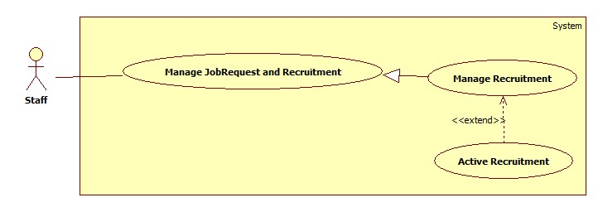

|  |  |  |  |  |
| --- | --- | --- | --- | --- |
| **USE CASE SPECIFICATION** | | | | |
| **Use-case No.** | UC045 | **Use-case Version** | | 1.0 |
| **Use-case Name** | Active Recruitment | | | |
| **Author** | CongNT | | | |
| **Date** | 21/09/2014 | **Priority** | High | |
| **Actor:** Staff  **Summary:** This use case allow staff to active job request to public it on website  **Goal:** Staff can allow job request to public on website  **Trigger:** User choose a recruitment then click “Chấp nhận” button  **Pre-conditions:**   * Page is loaded successfully * User login as staff successful   **Post conditions:**   * Success: Login successfully, the job request will be allowed to public on website * Failure:   **Main Success Scenario:**   |  |  | | --- | --- | | Actor Action | System Response | | 1. Login as a staff 2. Click “Xác nhận hoàn tất công việc” link 3. Choose a recruitment, click “Hoàn tất” button 4. Click “Chấp nhận” button. | 1. System redirect to list of job request 2. System redirect to list of applied job requests 3. System show a “Xác nhận kích hoạt” pop up. 4. Change IsActive(false) to IsActive(true) and save change to database |   **Alternative Scenario:**   |  |  | | --- | --- | | Actor Action | System Response | | 1. Click on the “Đăng xuất” button. | 1. Clear session and back to home page |   **Exceptions:**   |  |  | | --- | --- | | Actor Action | System Response | | 1. System fail to load data | 1. Show message “Hệ thống đang bảo trì” |   **Relationships:** N/A  **Business Rules:** User login as a staff and the website load all | | | | |

###### **<Staff> Approve JobRequest**

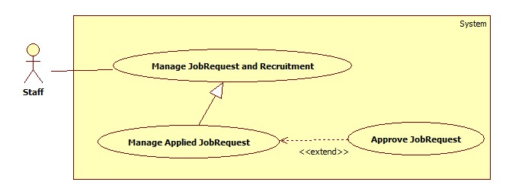

|  |  |  |  |  |
| --- | --- | --- | --- | --- |
| **USE CASE SPECIFICATION** | | | | |
| **Use-case No.** | UC046 | **Use-case Version** | | 1.0 |
| **Use-case Name** | Approve JobRequest | | | |
| **Author** | CongNT | | | |
| **Date** | 21/09/2014 | **Priority** | High | |
| **Actor:** Staff  **Summary:** This use case allow staff to active job request to public it on website  **Goal:** Staff can allow job request to public on website  **Trigger:** User choose a jobrequest then click “Kích hoạt” button  **Pre-conditions:**   * Page is loaded successfully * User login as staff successful   **Post conditions:**   * Success: Login successfully, the job request will be allowed to public on website * Failure:   **Main Success Scenario:**   |  |  | | --- | --- | | Actor Action | System Response | | 1. Login as a staff 2. Click “Kích hoạt yêu cầu tìm người” link 3. Choose a recruitment, click “Kích hoạt” button 4. Click “Chấp nhận” button. | 1. System redirect to list of job request 2. System redirect to list of recruitments 3. System show a “Xác nhận kích hoạt” pop up. 4. Change IsActive(false) to IsActive(true) and save change to database |   **Alternative Scenario:**   |  |  | | --- | --- | | Actor Action | System Response | | 1. Click on the “Đăng xuất” button. | 1. Clear session and back to home page |   **Exceptions:**   |  |  | | --- | --- | | Actor Action | System Response | | 1. System fail to load data | 1. Show message “Hệ thống đang bảo trì” |   **Relationships:** N/A  **Business Rules:** Staff | | | | |

###### **<Staff> Manage JobRequest**

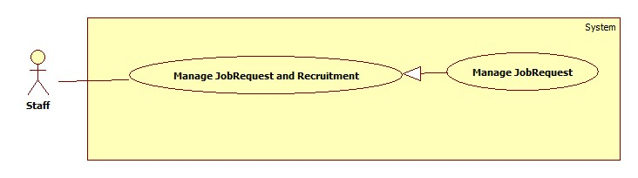

|  |  |  |  |  |
| --- | --- | --- | --- | --- |
| **USE CASE SPECIFICATION** | | | | |
| **Use-case No.** | UC052 | **Use-case Version** | | 1.0 |
| **Use-case Name** | Manage jobrequest | | | |
| **Author** | CongNT | | | |
| **Date** | 21/09/2014 | **Priority** | High | |
| **Actor:** Staff  **Summary:** This use case allow staff view all jobrequests that is not active  **Goal:** Staff can view all jobrequests that is not active  **Trigger:** User click “Quản lý” link  **Pre-conditions:**   * Page is loaded successfully * User login as staff successful   **Post conditions:**   * Success: Login successfully, the job request will be allowed to public on website * Failure:   **Main Success Scenario:**   |  |  | | --- | --- | | Actor Action | System Response | | 1. Login as a staff | 1. System redirect to list of job request |   **Alternative Scenario:**   |  |  | | --- | --- | | Actor Action | System Response | | 1. Click on the “Đăng xuất” button. | 1. Clear session and back to home page |   **Exceptions:**   |  |  | | --- | --- | | Actor Action | System Response | | 1. System fail to load data | 1. Show message “Hệ thống đang bảo trì” |   **Relationships:** N/A  **Business Rules:** User login as a staff. The website load all jobrequests that is not active. Staff choose a jobrequest. When user choose post time for jobrequest to post on website, after that time if jobrequest is not active, it will be remove from database. | | | | |

###### **<Staff> Manage Recruitment**

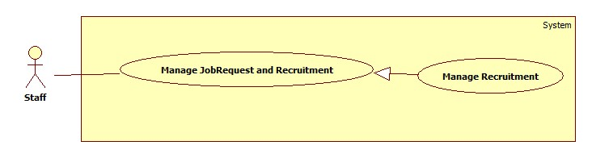

|  |  |  |  |  |
| --- | --- | --- | --- | --- |
| **USE CASE SPECIFICATION** | | | | |
| **Use-case No.** | UC053 | **Use-case Version** | | 1.0 |
| **Use-case Name** | Manage recruitment | | | |
| **Author** | CongNT | | | |
| **Date** | 21/09/2014 | **Priority** | High | |
| **Actor:** Staff  **Summary:** This use case allow staff view all recruitments that is not active  **Goal:** Staff can view all recruitments that is not active  **Trigger:** User click “Quản lý” link, then click “Kích hoạt yêu cầu tìm việc” link  **Pre-conditions:**   * Page is loaded successfully * User login as staff successful   **Post conditions:**   * Success: Login successfully, the recruitments will be allowed to public on website * Failure:   **Main Success Scenario:**   |  |  | | --- | --- | | Actor Action | System Response | | 1. Login as a staff 2. Click “Kích hoạt yêu cầu tìm người” link | 1. System redirect to list of job request 2. System redirect to list of recruitment |   **Alternative Scenario:**   |  |  | | --- | --- | | Actor Action | System Response | | 1. Click on the “Đăng xuất” button. | 1. Clear session and back to home page |   **Exceptions:**   |  |  | | --- | --- | | Actor Action | System Response | | 1. System fail to load data | 1. Show message “Hệ thống đang bảo trì” |   **Relationships:** N/A  **Business Rules:** User login as a staff. The website load all recruitments that is not active. Staff choose a recruitment. When user choose post time for recruitment to post on website, after that time if recruitment is not active, it will be remove from database. | | | | |

###### **<Staff> Manage Applied JobRequest**

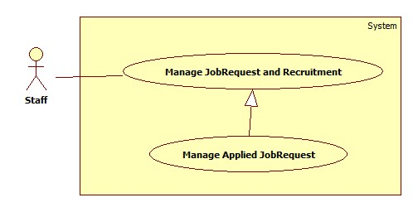

|  |  |  |  |  |
| --- | --- | --- | --- | --- |
| **USE CASE SPECIFICATION** | | | | |
| **Use-case No.** | UC054 | **Use-case Version** | | 1.0 |
| **Use-case Name** | Manage applied jobrequest | | | |
| **Author** | CongNT | | | |
| **Date** | 21/09/2014 | **Priority** | High | |
| **Actor:** Staff  **Summary:** This use case allow staff view all applied jobrequests  **Goal:** Staff can view all applied jobrequests  **Trigger:** User click “Quản lý” link, then click “Xác nhận hoàn tất công việc” link  **Pre-conditions:**   * Page is loaded successfully * User login as staff successful   **Post conditions:**   * Success: Login successfully, the recruitments will be allowed to public on website * Failure:   **Main Success Scenario:**   |  |  | | --- | --- | | Actor Action | System Response | | 1. Login as a staff 2. Click “Hoàn tất yêu cầu” link | 1. System redirect to list of job request 2. System redirect to list of applied jobrequest |   **Alternative Scenario:**   |  |  | | --- | --- | | Actor Action | System Response | | 1. Click on the “Đăng xuất” button. | 1. Clear session and back to home page |   **Exceptions:**   |  |  | | --- | --- | | Actor Action | System Response | | 1. System fail to load data | 1. Show message “Hệ thống đang bảo trì” |   **Relationships:** N/A  **Business Rules:** User login as a staff. The website load all applied jobrequests. | | | | |

### Software System Attributes

#### Reliability

* There is no requirement for system maintenance task from the user.
* Mean Time Between Failures (MTBF): more than 6 months.
* Accuracy: 100%.
* Maximum Bugs and Defect Rate: 0.3 bugs per thousand lines of code (0.3bugs/KLOC).
* Critical bugs:
* Loss of data: not any

#### Availability

* The server shall be working 24 hours per day and 7 days per week.

#### Security

* *All sensitive* information (password, etc.) must be hashed when storing in database and during transmission over networks using MD5 hash.
* Validate input data in SQL query before execute to avoid SQL Injection, XSS
* The role of user and member is clearly.

#### Maintainability

* All code shall fully document. All program files shall include comments concerning authorship and date of last change.
* The code shall be modular to permit future modifications.

#### Portability

* The software will design as cross-platform software.

#### Performance

* Large tables and indexes must be partitioned data into smaller, more manageable sections by using partition in SQL Server 2008 R2

## Entity Relationship Diagram or Data Structures

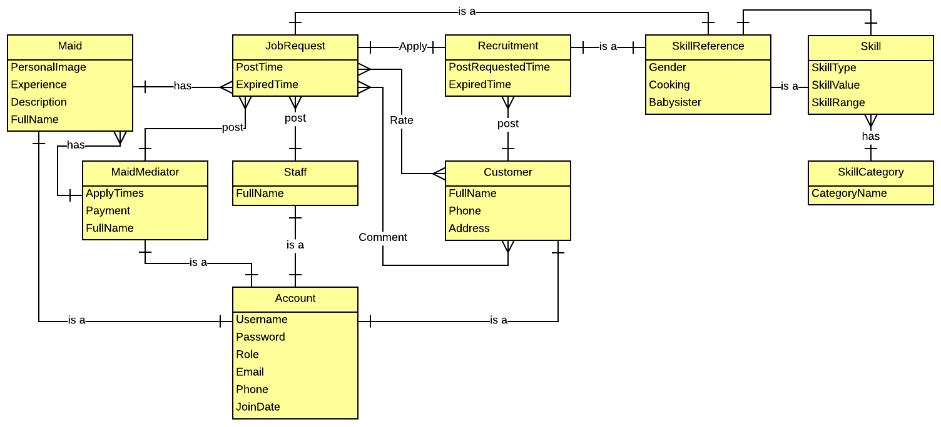

## Other material (if any)

N/A